

#CLUS



How to migrate a   
MPLS network from RSVP-TE to SR-TE

Thomas Wang, Technical Marketing Engineer BRKMPL-2130

#CLUS

Cisco Webex Teams   
Questions? 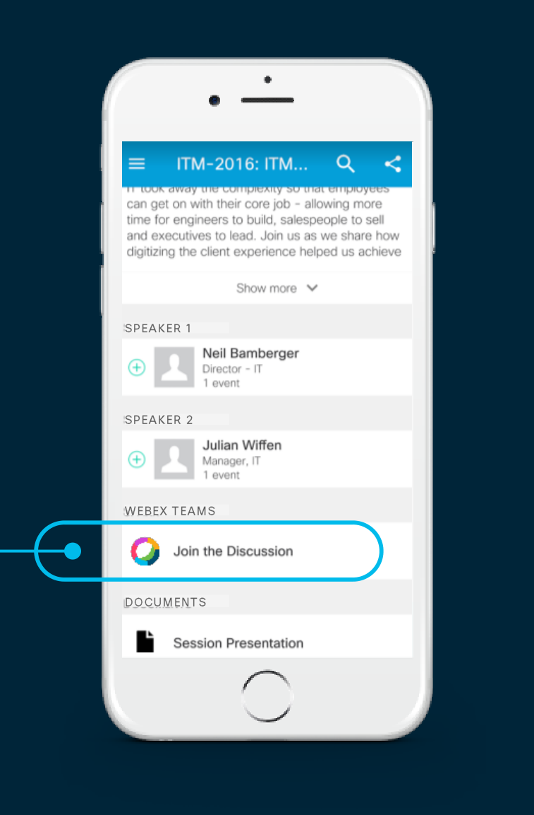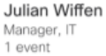

Use Cisco Webex Teams to chat

with the speaker after the session

How

|  |  |  |  |  |  |
| --- | --- | --- | --- | --- | --- |
| 1 | Find this session in the Cisco Live Mobile App | |  |  |  |
| 2 | Click “Join the Discussion” | |  |  |  |
| cs.co/ciscolivebot# |
| 3 | Install Webex Teams or go directly to the team space | | BRKMPL-2130 | 3 |
| 4 | Enter messages/questions in the team space | |
| Webex Teams will be moderated | | |
| by the speaker until June 16, 2019. | | |
|  | | #CLUS | © 2019 Cisco and/or its affiliates. All rights reserved. Cisco Public | |

Agenda

• Welcome and Introduction  
• RSVP-TE Network Challenges   
• Solution Overview of Network Migration• SR-TE Policies and Traffic Steering  
• RSVP-TE Bandwidth Accounting  
• Key Takeaways

|  |  |  |  |  |
| --- | --- | --- | --- | --- |
|  | #CLUS | BRKMPL-2130 | © 2019 Cisco and/or its affiliates. All rights reserved. Cisco Public | 4 |

Objective

• Introduce a solution that facilitates migration by allowing

the coexistence of non-zero bandwidth RSVP-TE tunnel

and Segment Routing in same network domain

❖ SR-TE Policy Setup and Traffic Steering Techniques

❖ SR Traffic Accounting and RSVP-TE resvBW Refresh

|  |  |  |  |  |
| --- | --- | --- | --- | --- |
|  | #CLUS | BRKMPL-2130 | © 2019 Cisco and/or its affiliates. All rights reserved. Cisco Public | 5 |



Reason of Network Migration   
RSVP-TE Network Challenges and SR Benefits



Today Business Drivers

|  |  |  |
| --- | --- | --- |
| Scalability | Optimization | Automation |

|  |  |  |  |  |
| --- | --- | --- | --- | --- |
|  | | | | |
| • Distribute massive traffic | • Feature richness to optimize | | • Telemetry and visibility | 7 |
| volumes | traffic steering | | • Model driven and machine |
| • High-scale system | • API programmability | | learning |
|  | #CLUS | BRKMPL-2130 | © 2019 Cisco and/or its affiliates. All rights reserved. Cisco Public |

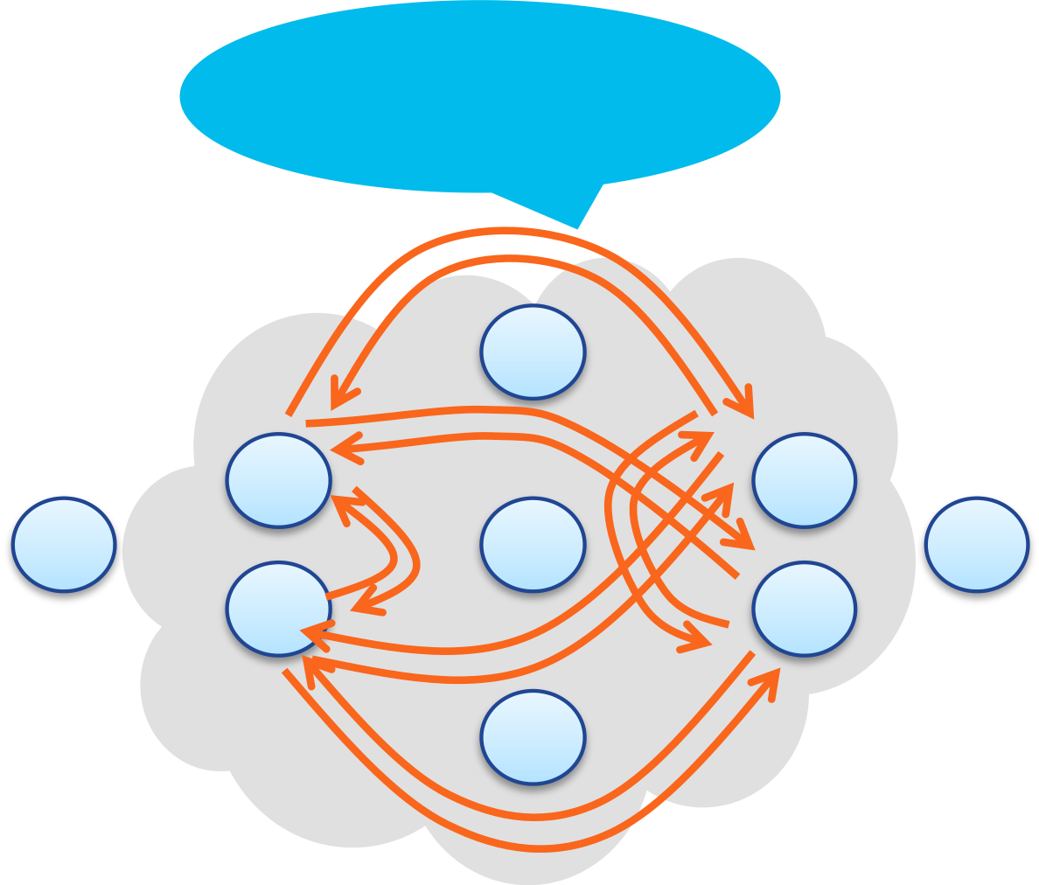

RSVP-TE Network Challenges

• Complicated MPLS WAN network• Full-mesh of RSVP-TE Tunnels

Headend scale:   
 8k → 16k → 32k→?

Midpoint scale:   
 64k→128k→256k→?

RSVP state maintained at every hop

|  |  |  |  |  |  |
| --- | --- | --- | --- | --- | --- |
| Large headend and midpoint scale | **A** | **B1** | **C1** | **D1** | **E** |
| Core state n^2 problem |
| Compounded by emerging new | **B2** | **C2** | **D2** |
| service SLAs |
| • Doesn’t scale well as network | **C3** |

continues to growth

|  |  |  |  |  |  |
| --- | --- | --- | --- | --- | --- |
|  | #CLUS |  | | RSVP-TE Full-Mesh | 8 |
| BRKMPL-2130 | © 2019 Cisco and/or its affiliates. All rights reserved. Cisco Public | |

Why Segment Routing?

• Simple   
❖ Reduced control plane state  
❖ Utilize existing MPLS data plane  
❖ Path Control with SR source routing label stack

• Agile and Scalable  
 ❖ Eliminate LDP, RSVP protocols

• Programmable   
❖ Centralized path computation option  
❖ Ability for application integration

|  |  |  |  |  |
| --- | --- | --- | --- | --- |
|  | #CLUS | BRKMPL-2130 | © 2019 Cisco and/or its affiliates. All rights reserved. Cisco Public | 9 |

SR Path Control and Ti-LFA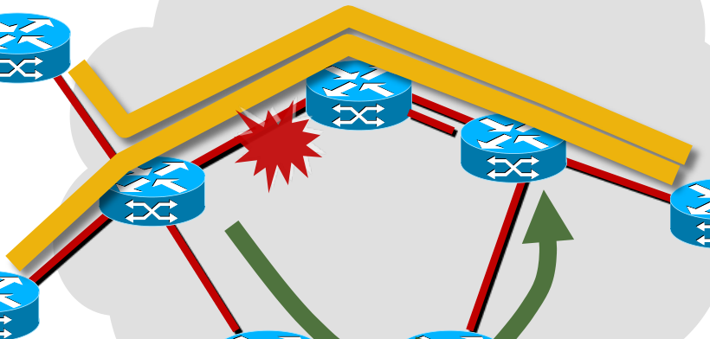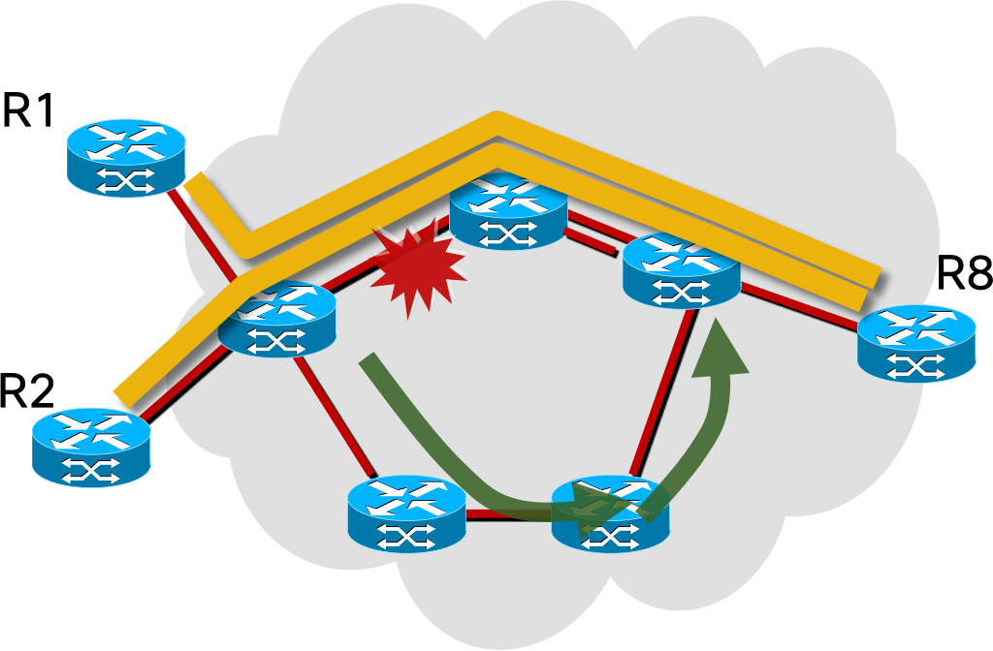

|  |  |  |  |  |  |
| --- | --- | --- | --- | --- | --- |
| Segment Routing Traffic Engineering (SR-TE) | | | | | • Source Routing   Source chooses a path and encodes in the packet header as an ordered list of segments  The rest of the network nodes executes the encoded instructions  • SR-TE Policy Path Control  Policy label stack with Node-SID, or Adj-SID Each Policy assigned unique Binding-SID ECMP paths load-balance by IGP Nature |
| R1 | MPLS | | | |
| **16001** | | | | |
| **16006** | | | | R8 |
| R2 | **16003** | **24001** | **16007** | **16008** |
| **16002** | | | | |
| **16004** | | | **16005** | |

• Topology Independent LFA  
❖ Automated 1:N path protection

|  |  |  |  |  |  |
| --- | --- | --- | --- | --- | --- |
|  | Primary LSP | #CLUS | ❖ Local reroute comparable to MPLS TE Link / | | 10 |
| Backup Segment | Node, but no RSVP or LDP | |
|  |
| ❖ IGP algorithm, support microloop avoidance | |
|  | BRKMPL-2130 | © 2019 Cisco and/or its affiliates. All rights reserved. Cisco Public |

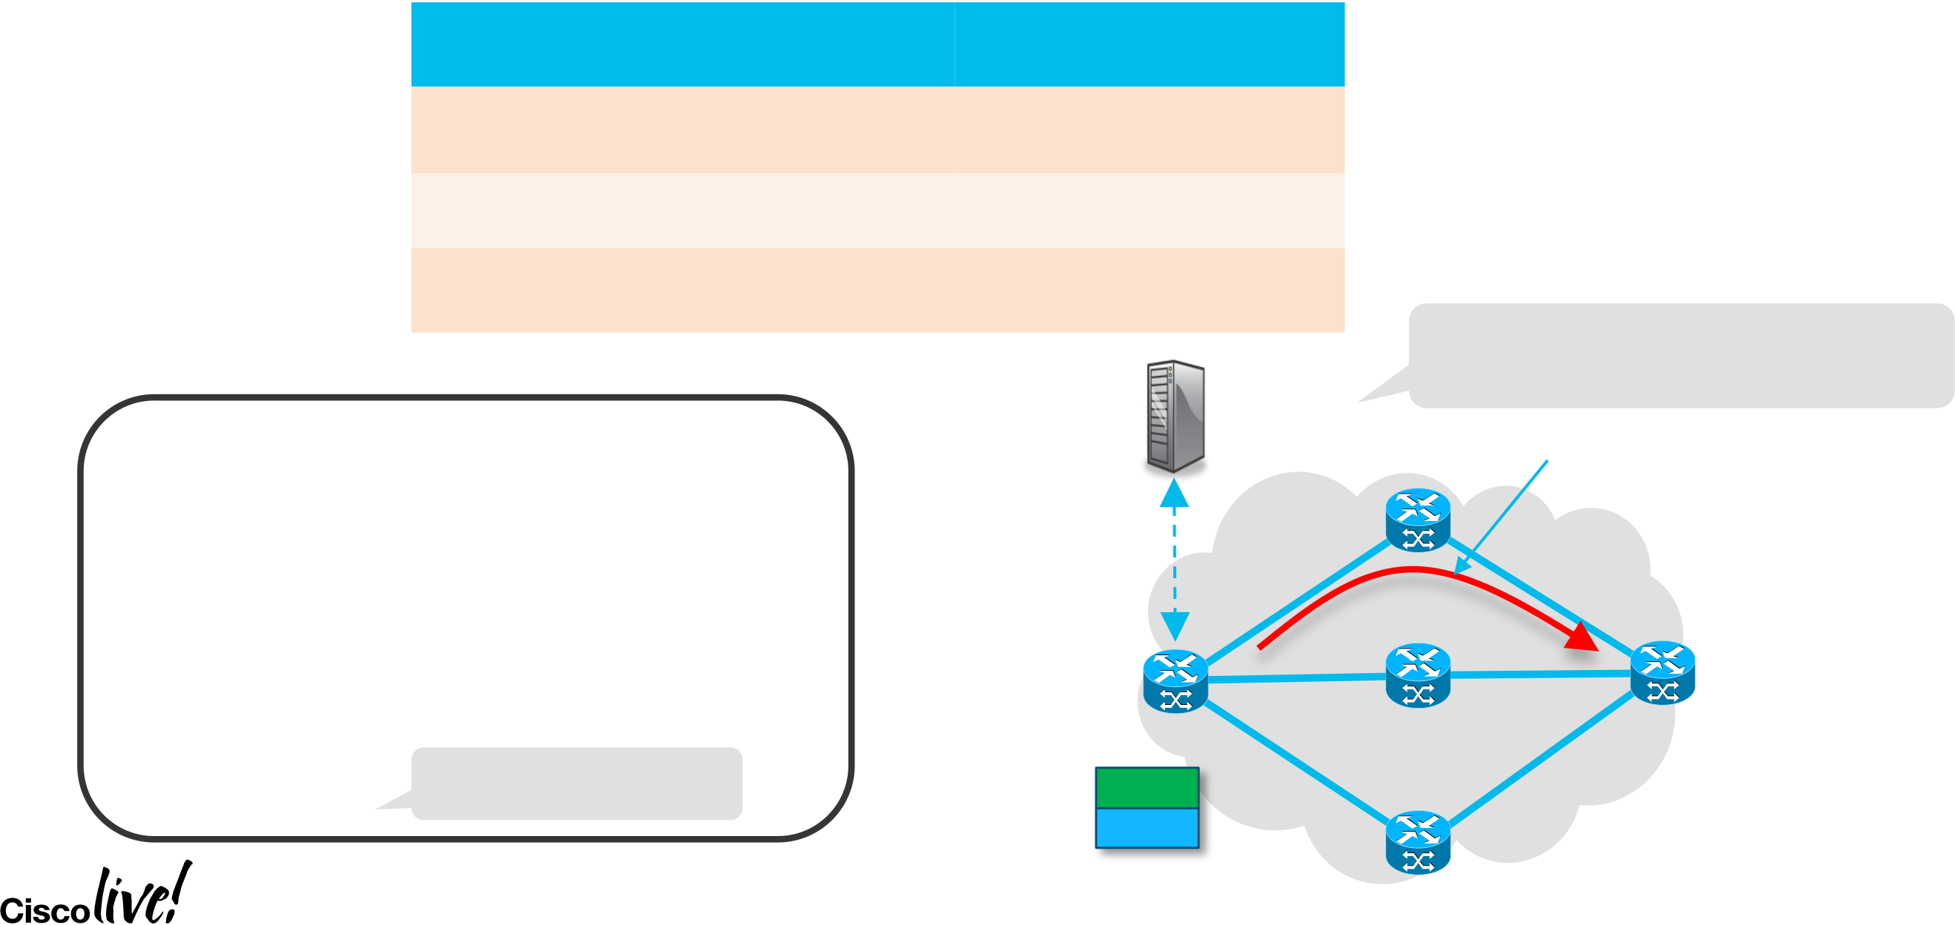

SR Centralized Path Computation

|  |  |  |
| --- | --- | --- |
| TE state only at head-end | SR-TE | RSVP-TE |
| Yes | No |
| ECMP-capability for TE | Yes | No |
| Engineered for SDN | Yes | Yes/No |

Segment Routing Path Computation

|  |  |  |  |  |
| --- | --- | --- | --- | --- |
| segment-routing | **PCEP** | **SR-PCE** | Element (SR-PCE) provides policy | |
| aware path computation | |
| **16001** | **RSVP-TE**  **tunnel** |
| traffic-eng |
| pcc | **+** | **16002** | **16005**  **Destination** |
| pce address ipv4 192.99.1.1 | **BGP-LS** |
| ! |
| policy foo123 | **PCC** |
| color 10 end-point ipv4 1.1.1.5 |
| autoroute | **Source** | **1.1.1.5** | |

candidate-paths

|  |  |  |  |  |  |
| --- | --- | --- | --- | --- | --- |
| preference 100 | SR Centralized Path | #CLUS | 16005 | **16003** | 11 |
| dynamic pcep |
| Computation |
| Data | © 2019 Cisco and/or its affiliates. All rights reserved. Cisco Public |
| BRKMPL-2130 |

RSVP-TE to SR-TE Seamless Migration

|  |  |  |  |  |  |  |
| --- | --- | --- | --- | --- | --- | --- |
| WHY   |  | | --- | | • Simple, easy and scalable   Avoid LDP or RSVP-TE sessions, less protocols to operate   Avoid midpoint of RSVP-TE LSP’s n^2 scale problem  • Enables Application Driven Programmability:    Programmatic interfaces and Orchestration | | | HOW   |  | | --- | | • MPLS data plane leveraged without any modification   Push, swap and pop: all SR forwarding need   Inherit SR label ECMP load balance  • SR Traffic engineering via IGP Source Routing   Source routing path control push as a SR label or stack of labels | | | |
|  | #CLUS | BRKMPL-2130 | © 2019 Cisco and/or its affiliates. All rights reserved. Cisco Public | 12 |



Solution Overview of Network Migration SR-TE Policies and Traffic Steering

Network Migration Approaches 

|  |  |  |  |
| --- | --- | --- | --- |
| |  | | --- | | Interworking   SR and RSVP-TE deployed in non overlapping areas of network  Isolated SR domains interconnected over RSVP-TE core  Within RSVP-TE domain, SR-TE label stack is carried inside RSVP-TE path | | |  | | --- | | Ships-in-the-night    SR-TE and RSVP-TE coexist over same network domain  Some services are migrated to SR, others retained on existing RSVP-TE RSVP-TE link-management admission- control unaware of SR traffic utilization | |

|  |
| --- |
| RSVP-TE and SR-TE Coexistence  In control plane: RSVP-TE and SR-TE independently program MPLS label forwarding entries In data plane: RSVP-TE and SR-TE use distinct MPLS labels |

|  |  |  |  |  |
| --- | --- | --- | --- | --- |
|  | #CLUS | BRKMPL-2130 | © 2019 Cisco and/or its affiliates. All rights reserved. Cisco Public | 14 |

IP and Label Switch Path Install 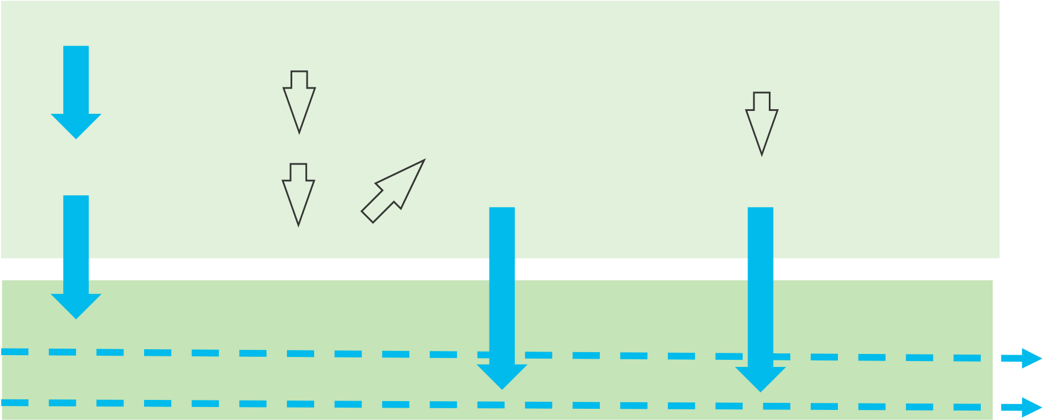

|  |  |  |  |  |  |  |  |  |
| --- | --- | --- | --- | --- | --- | --- | --- | --- |
| |  | | --- | | RSVP-TE  RSVP-TE Signaling (label distribution) Autoroute Announce via IGP  Fast-reroute link/node protection | | | | | | |  | | --- | | SR-TE  IGP Label distribution, inherent ECMP Auto Steering via BGP Prefix Coloring Topology Independent LFA | | |
| CONTROL | PLANE | IGP (LSDB) | mpls traffic-eng | RSVP-TE | | Segment Routing + |
| extensions |
| MPLS TE Extensions |
| Routing | TE DB | SR-TE DB |
| Table (RIB) | Signaling | |

Constraint SPF

|  |  |  |  |  |  |  |
| --- | --- | --- | --- | --- | --- | --- |
| DATA | PLANE | Forwarding Table (FIB) | #CLUS | BRKMPL-2130 | IP Traffic | 15 |
| Label Forwarding Table (LFIB) | LSP |
|  | © 2019 Cisco and/or its affiliates. All rights reserved. Cisco Public |

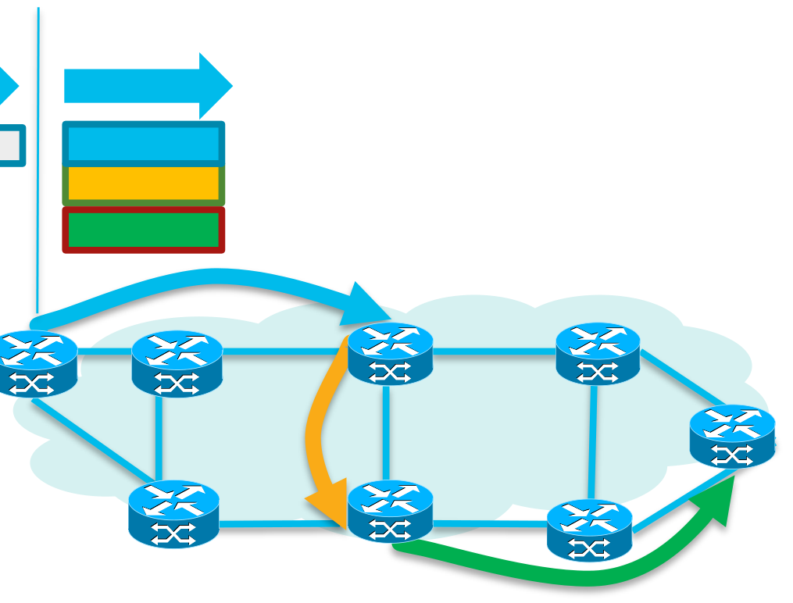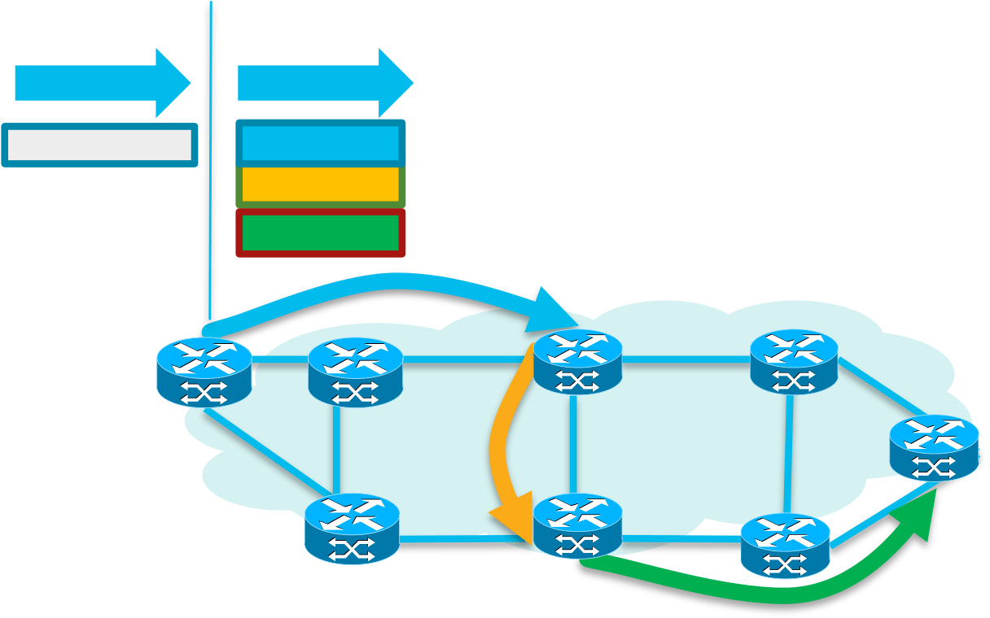

SR-TE Auto-Steering with BGP Prefix Coloring

|  |  |  |
| --- | --- | --- |
| SR-TE provides more granular and | IP: color, DST | SR-TE Policy |
| automated steering techniques |
| Egress BGP route-policy advertised prefixes | LBL: 99999 | (color, endpoint) |
| colors using extended community attributes | IN | OUT |

Incoming traffic is steered over SR-TE policy:

|  |  |  |  |  |  |
| --- | --- | --- | --- | --- | --- |
| ➢ IP per flow traffic is steered if BGP prefix matches | | BSID:99999 | 16003 | | **Z** |
| **A** | 24086 | |
| color and endpoint | |
| 16008 | |
| ➢ labeled traffic is steered if packet top label matches | |
| 16003 | **C** |
| policy Binding-SID | |
| Auto-steering applies in same way regardless of | |
| 24086 | |
| local or automatic SR-TE policy types | |
| BRKMPL-2130 | **O** | | 16008 |
| If no valid SR-TE policy exists, prefixes will be | |
| installed "classically" in the forwarding plane by | |
| recursive lookup on the route to next-hop | |
| 16 |
|  | #CLUS |
| © 2019 Cisco and/or its affiliates. All rights reserved. Cisco Public | |

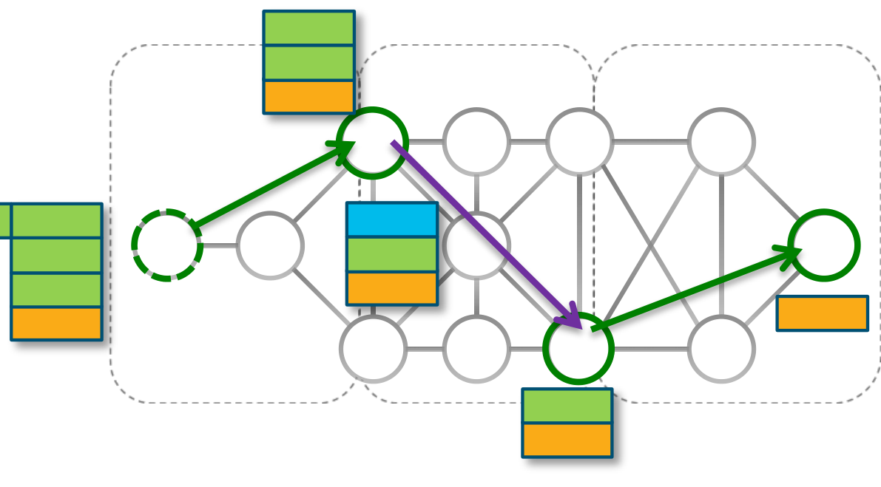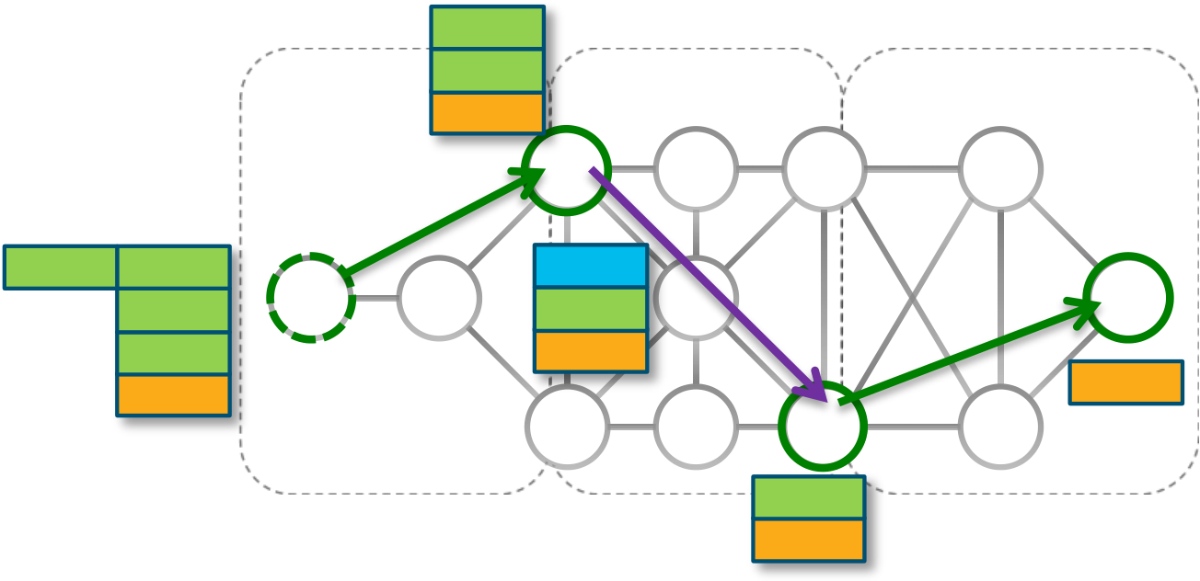

SR-TE to RSVP-TE Interworking  
• Extends an existing network where RSVP-TE is deployed

❖ Enable SR in the network in islands, leave legacy RSVP-TE network in places

❖ SR-TE interwork with RSVP-TE through Binding-SID as part of SRTE label stack

• SR-TE Policy "stitches" RSVP-TE tunnel by using Binding-SID of

RSVP-TE tunnel

24009

|  |  |  |  |  |  |  |  |  |  |
| --- | --- | --- | --- | --- | --- | --- | --- | --- | --- |
| 99999 | 16003 | 1 | SR | 16021 Data | RSVP-TE | | 5 | SR | 21 |
| 2 | | 3 | 4 | 22 |
| 24000 16021 | 6 |
| 24009 |
| 16021 | Data | | 9 | 23 | Data |
| Data | 7 | 8 |

16021

|  |  |  |  |  |  |
| --- | --- | --- | --- | --- | --- |
|  | #CLUS | Data | BRKMPL-2130 | © 2019 Cisco and/or its affiliates. All rights reserved. Cisco Public | 17 |

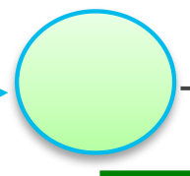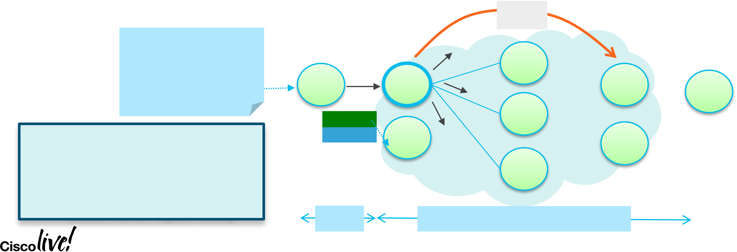

Ships-in-the-night: SR-TE and RSVP-TE Coexist

• Some services deployed over SR, others over existing transport (LDP or RSVP-TE)• Data plane routes to native IGP SR path or SRTE policy by color and B-SID match• Gradually move traffic from RSVP-TE Autoroute Announce steering to SR-TE color

|  |  |  |  |  |  |  |
| --- | --- | --- | --- | --- | --- | --- |
| based Auto-steering | **A** | 160D1 | **B1** | RSVP-TE | IP address: 1.1.1.D1 | |
| int tunnel-te 1000 | B1-D1 |
| destination D1 | **C1** |
| node-sid: 160D1 | |
| autoroute-announce |
| exclude-traffic | **D1** | **E** |
| segment-routing |
| **R1# show mpls traffic-eng autoroute** | **B2** | **C2** | **D2** | |
| IP |
| Destination 1.1.1.5 has 1 tunnels in IS-IS |

10 level 2

|  |  |
| --- | --- |
| tunnel-te1000 (traffic share 0, nexthop 1.1.1.5, metric 0) | **C3** |

(IS-IS 10 level-2, IPV4 Unicast)

Signalled-Name: R1_t1000

|  |  |  |  |  |
| --- | --- | --- | --- | --- |
| Exclude-traffic: segment-routing | IGP-SR | RSVP-TE Full-Mesh + IGP-SR | | 18 |
| #CLUS | BRKMPL-2130 | © 2019 Cisco and/or its affiliates. All rights reserved. Cisco Public |

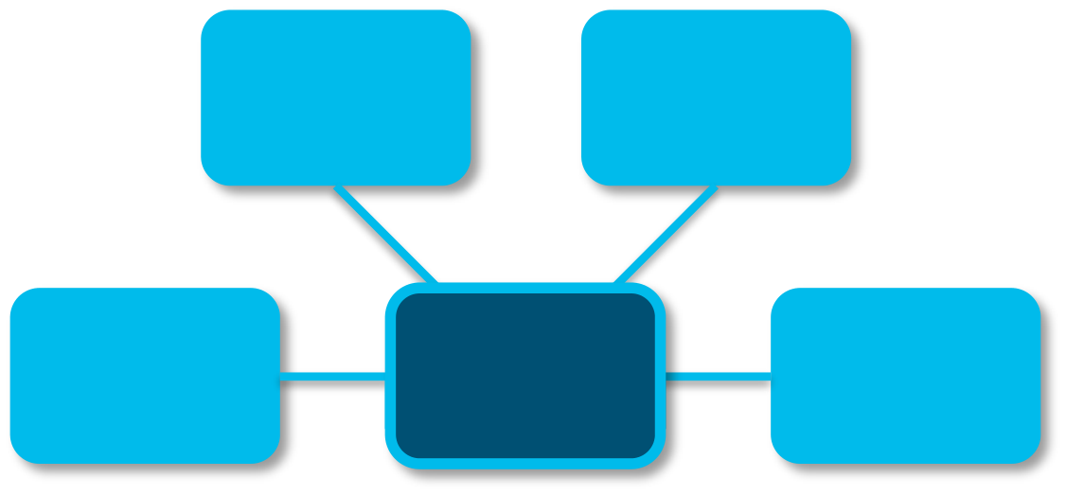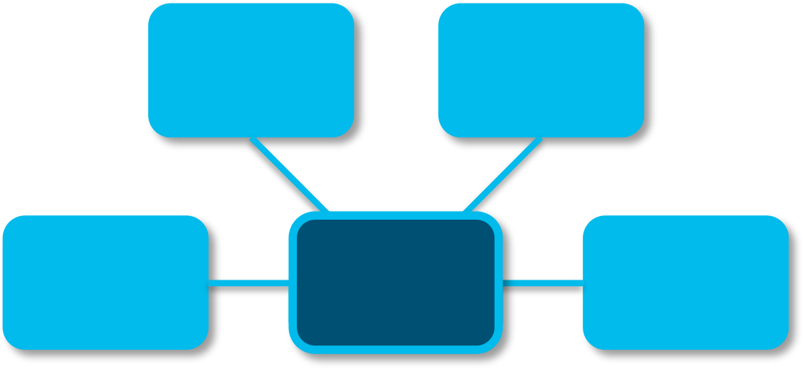

Traffic Engineering with Segment Routing

• Automated On-Demand Policy  
❖ No core state: state in the packet header  
❖ Automated steering: BGP prefix coloring  
❖ No tunnel interface: on-demand policy instantiation

|  |  |  |
| --- | --- | --- |
| • CLI or Controller Based Policy | BGP | PCEP |

❖ Support constraint-based routing  
❖ CLI is just one way, more programmable ways

|  |  |  |  |
| --- | --- | --- | --- |
| ❖ Support controller based BGP sr-policy instantiation | CLI | SR-TE | netconf |
| • Centralized Multi-Domain Policy |

❖ SR Path Compute Element (SR-PCE) for path compute Binding-SID (BSID) for traffic steering and scale  
❖ Supports centralized policy via PCEP provision

|  |  |  |  |  |
| --- | --- | --- | --- | --- |
|  | #CLUS | BRKMPL-2130 | © 2019 Cisco and/or its affiliates. All rights reserved. Cisco Public | 19 |



Use Case1: CLI SRTE Policy with Autoroute

|  |  |  |  |  |  |  |  |  |  |
| --- | --- | --- | --- | --- | --- | --- | --- | --- | --- |
| segment-routing  traffic-eng   policy POLICY1   color 2 end-point ipv4 1.1.1.4 autoroute   include ipv4 10.10.1.0/24   binding-sid mpls 999 | | • BGP installs SR-TE policy data path with policy B-SID  Path with higher preference is preferred • SR-TE policy autoroute includes specific prefix   Remaining IGP autoroute traffic over RSVP-TE tunnels is not impacted | | | | | | | |
| ➊ | candidate-paths  preference 100 | ➋ | 2 | | **20** | | 3 | IGP: | |
| dynamic  metric   type te | |
| 10.10.1.0/24 | |
| ➋ | preference 200  explicit segment-list SIDLIST1 |
| 1 | 4 | | | | | | |
| !  segment-list name SIDLIST1 index 10 mpls label 16002 index 20 mpls label 24004 index 30 mpls label 16004 | |
| ➊  Node1 | | 6 | | 5 | | | |
| Default link metric: 10 | | | | | |
| #CLUS | BRKMPL-2130 | | © 2019 Cisco and/or its affiliates. All rights reserved. Cisco Public | | | | 20 |

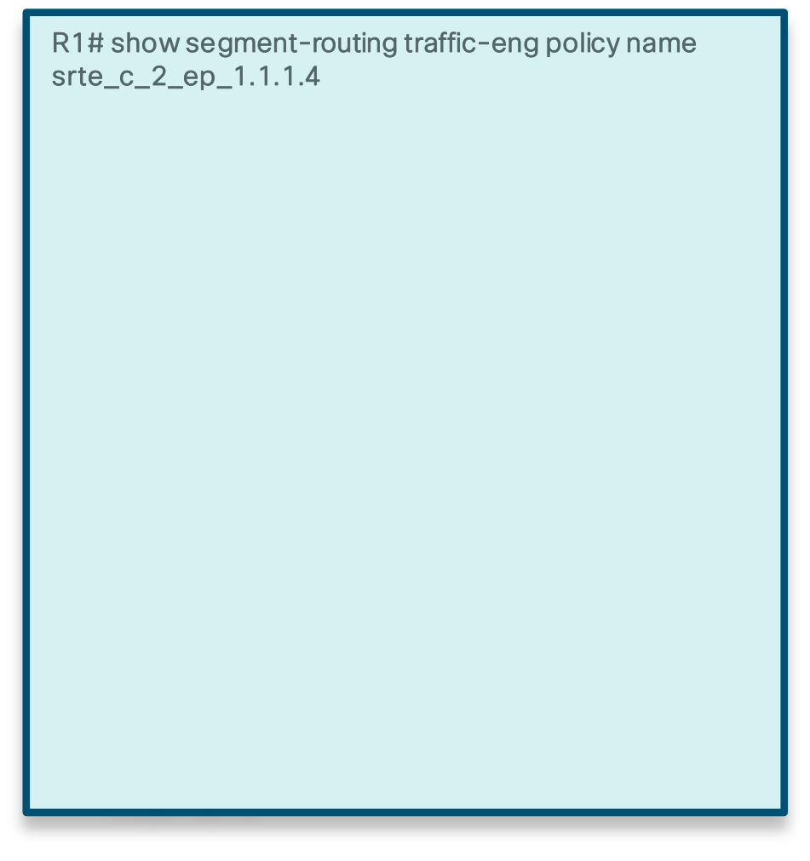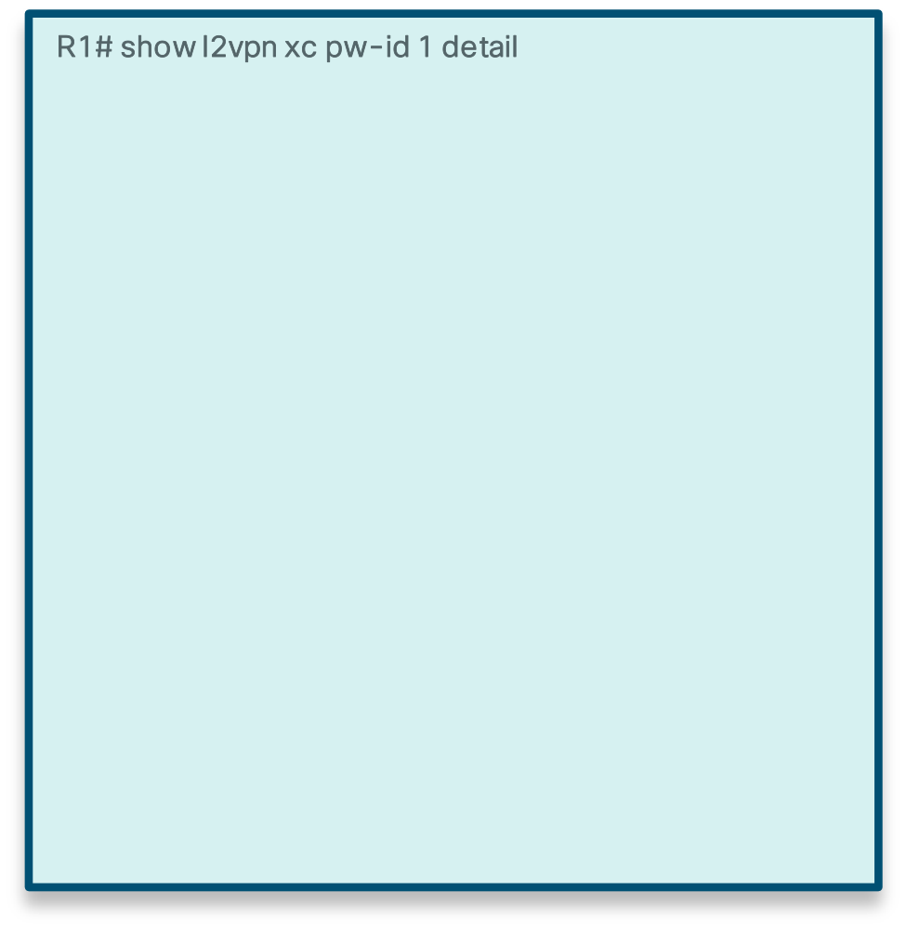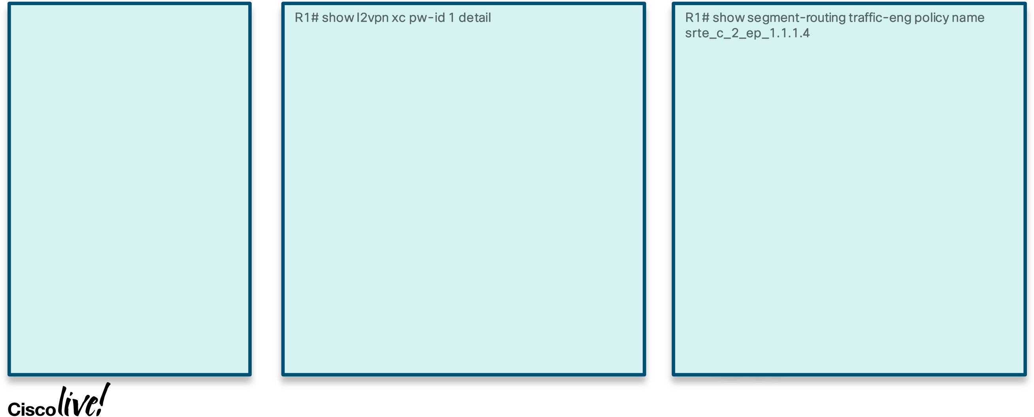

L2VPN Service Preferred-path Steering

• Use preferred-path configuration to specify SR-TE Policy used to transport Pseudowire traffic

|  |  |  |
| --- | --- | --- |
| l2vpn | R1# show l2vpn xc pw-id 1 detail | R1# show segment-routing traffic-eng policy name |
| pw-class EoMPLS-PWCLASS | Group vpws, XC vpws1, state is up; Interworking none | srte_c_2_ep_1.1.1.4 |
| encapsulation mpls | AC: Bundle-Ether2.2, state is up | Color: 2, End-point: 1.1.1.4 |
| preferred-path sr-te policy policy | … | Name: srte_c_2_ep_1.1.1.4 |
| srte_c_2_ep_1.1.1.4 | PW: neighbor 1.1.1.4, PW ID 1, state is up ( established ) | Status: |
| ! | PW class xc-vpls, XC ID 0xa000001f | Admin: up Operational: up for 02:48:30 (since Apr 1 |
| xconnect group vpws | Encapsulation MPLS, protocol LDP | 12:22:57.663) |
| p2p vpws1 | Source address 1.1.1.1 | Candidate-paths: |
| interface Bundle-Ether2.2 | PW type Ethernet, control word disabled, interworking | Preference: 200 (configuration) (active) |
| neighbor ipv4 1.1.1.4 pw-id 1 | none | Name: POLICY1 |
| pw-class EoMPLS-PWCLASS | PW backup disable delay 0 sec | Requested BSID: 999 |
| ! | Sequencing not set | PCC info: |
| Preferred path Active : SR TE srte_c_2_ep_1.1.1.4, | Symbolic name: cfg_ POLICY1_discr_200 |
| Statically configured, fallback disabled | PLSP-ID: 4 |
| Tunnel: Up | Explicit: segment-list SIDLIST1 (valid) |

Weight: 1, Metric Type: TE   
 16002 [Prefix-SID, 1.1.1.2]   
 24004 [Adjacency-SID, 10.23.0.1 - 10.23.0.2]   
 16004 [Prefix-SID, 1.1.1.4]   
Preference: 100 (configuration)   
Requested BSID: 999   
PCC info:   
 Symbolic name: cfg_POLICY1_discr_100   
 PLSP-ID: 6

|  |  |  |  |
| --- | --- | --- | --- |
| #CLUS | BRKMPL-2130 | © 2019 Cisco and/or its affiliates. All rights reserved. Cisco Public | 21 |

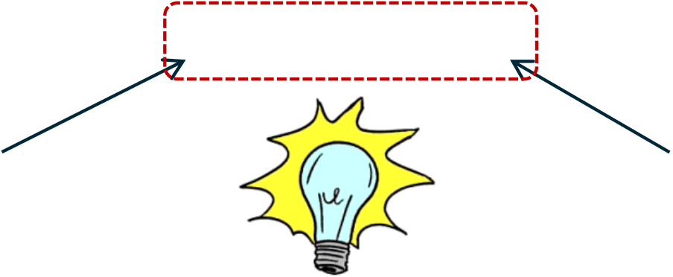

Use Case2: On-demand SRTE Policy

• Service source automatically instantiates an SRTE Policy to a BGP next-hop on-demand based on a BGP prefix color-template  One binding-sid per auto-policy, no need to pre-configured

• Service headend installs Policy data path based on binding-sid  Color match Auto-steering, no impact on RSVP-TE IGP autoroute traffic

• BGP prefix traffic automatically steered over SR-TE Policy based on Color community and BGP next-hop  
 ❖ Color community is used as SLA indicator  
 ❖ Each SR Policy is defined by (color, endpoint)

|  |  |  |  |  |  |
| --- | --- | --- | --- | --- | --- |
|  | BGP Color | #CLUS | BGP | | 22 |
| Next-hop | |
| Community |
| BRKMPL-2130 | © 2019 Cisco and/or its affiliates. All rights reserved. Cisco Public |

Internet Service On-demand Policy Steering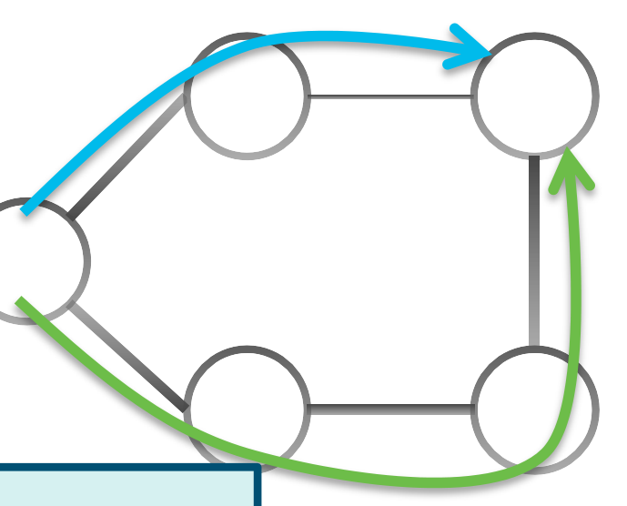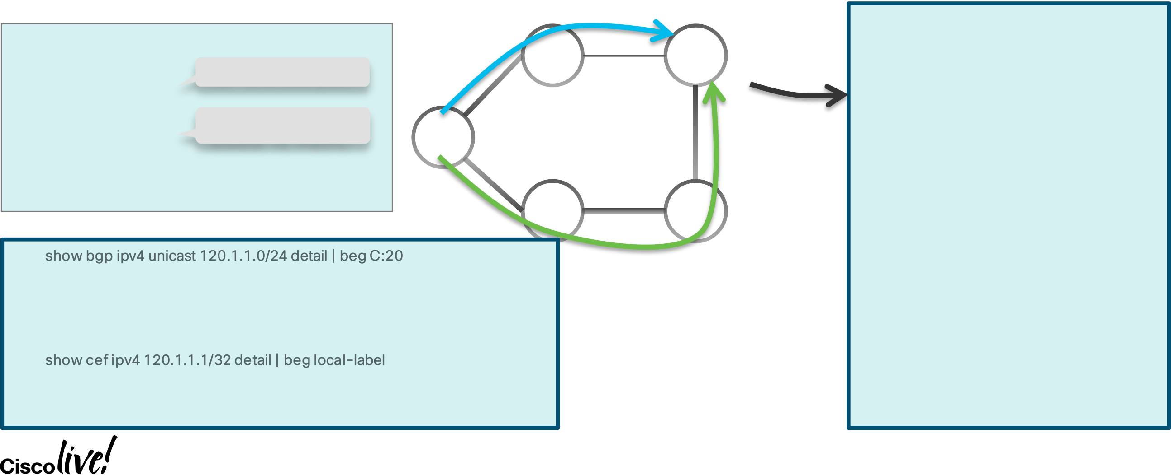

|  |  |  |
| --- | --- | --- |
| IF | => | THEN |
| BGP prefix next-hop and color match | BGP route is installed and resolved |
| SR-TE Policy endpoint and color |
| with SR-TE Policy BSID |

extcommunity-set opaque BLUE

|  |  |  |  |  |  |  |  |  |
| --- | --- | --- | --- | --- | --- | --- | --- | --- |
| segment-routing  traffic-eng | srte_c_10 | | 2 | 3 | 110.1.1.0/24 | | 10 | 23 |
| end-set |
| 120.1.1.0/24 | |
| on-demand color 10 | IGP shortest path | | ! |
| dynamic metric type igp | | | iBGP | extcommunity-set opaque GREEN | | | |
| on-demand color 20 | better path with | 1 | 20 | | | |
| dynamic metric type te | end-set | | | |
| lowest TE metric |
| ! | ISIS v4 | ! | | | |
| route-policy SET_COLOR | | | |
| 110.1.1.3/32 (color 10, NH 1.1.1.3, srte_c_10) | | | 5 | if destination in (110.1.1.0/24) then | | | |
| 120.1.1.3/32 (color 20, NH 1.1.1.3, srte_c_20) | | | 4 | set extcommunity color BLUE  endif  if destination in (120.1.1.0/24) then | | |
| srte_c_20 | | |
| R1# show bgp ipv4 unicast 120.1.1.0/24 detail | beg C:20 | | | #CLUS | set extcommunity color GREEN | | | |
| endif | | | |
| 1.1.1.3 C:20 (bsid:24025) (metric 20) from 1.1.1.3 (1.1.1.3) | | |
| pass | | | |
| Origin incomplete, metric 0, localpref 100, valid, internal, best, group-best | | |
| end-policy | | | |
| Received Path ID 0, Local Path ID 1, version 25 | | |
| ! | | | |
| Extended community: Color:20 | | |
| router bgp 1 | | | |
| SR policy color 20, up, registered, bsid 24025, if-handle 0x00000270 | | |
| neighbor 1.1.1.1 | | | |
| R1# show cef ipv4 120.1.1.1/32 detail | beg local-label | | |
| remote-as 1 | | | |
| via local-label 24025, 3 dependencies, recursive [flags 0x6000] | | |
| update-source Loopback0 | | | |
| Hash OK Interface Address | | |
| address-family ipv4 unicast | | | |
| 0 Y srte_c_20_ep_1.1.1.3 point2point | | |
| route-policy SET_COLOR out | | | |
| BRKMPL-2130 | | © 2019 Cisco and/or its affiliates. All rights reserved. Cisco Public | |

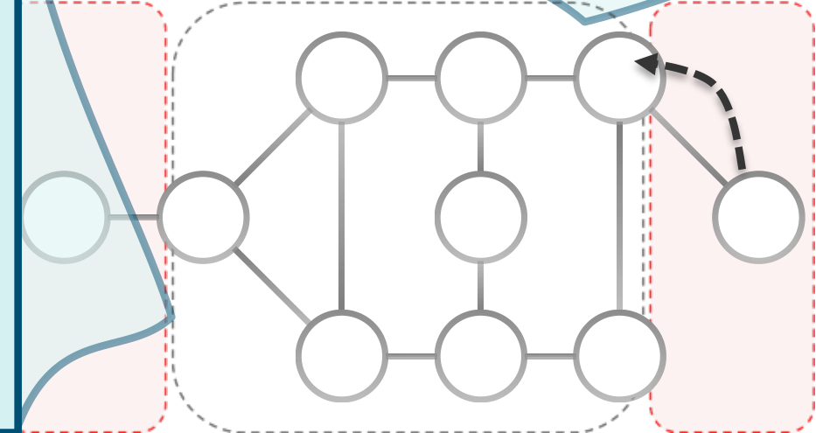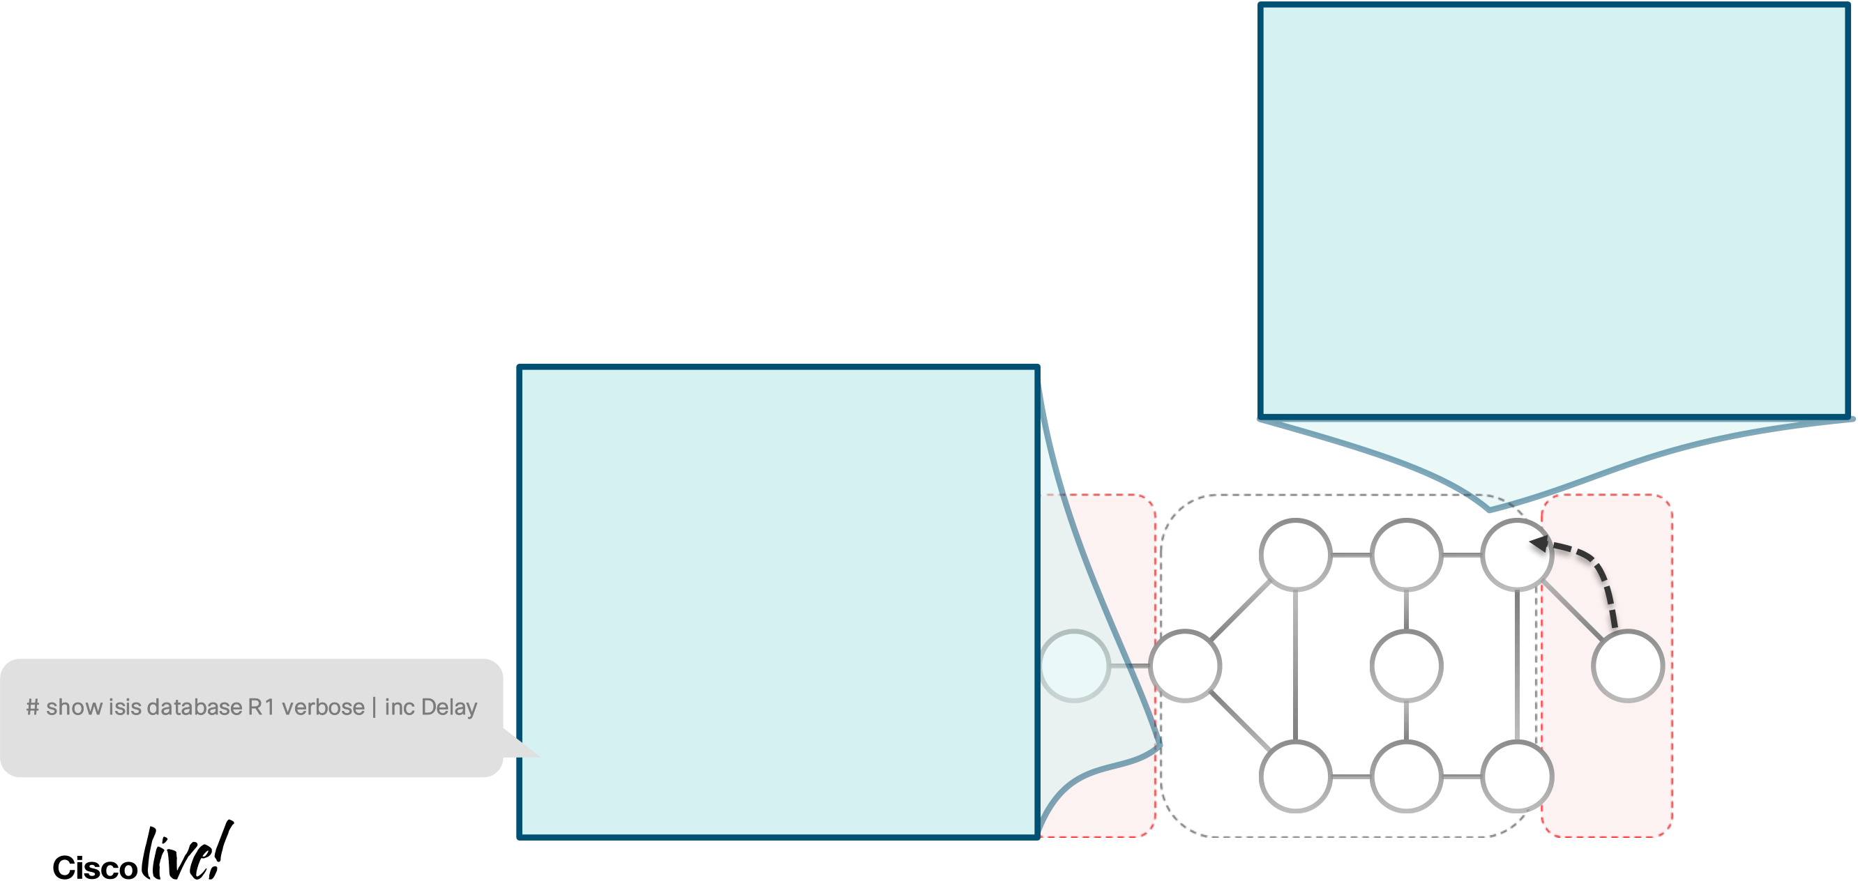

Use Case3: Dynamic VPN SRTE Policy

|  |  |
| --- | --- |
| • Egress PE5 populates a vrf prefix 11.11.1.0/24 requires low latency service | extcommunity-set opaque color2 2  end-set  ! |

=> PE5 tags with extcommunity “color2”

route-policy bgp_col   
if destination in (11.11.1.0/24) then   
 set extcommunity color color2

|  |  |
| --- | --- |
| • Ingress PE2 initiates on-demand policy by color template => PE2 finds a path to PE5 with optimized metric latency | endif  end-policy  !  router bgp 1  neighbor 1.1.1.2 |

remote-as 1

|  |  |
| --- | --- |
| router bgp 1  neighbor 1.1.1.5 | address-family vpnv4 unicast  route-policy bgp_col out |

address-family vpnv4 unicast   
vrf RED   
rd 2:2

|  |  |  |  |  |  |
| --- | --- | --- | --- | --- | --- |
| address-family ipv4 unicast | 3 | 4 | T:30 | 5 | BGP: |
| ! | 11.11.1.0/24, via 10 |
| segment-routing |

traffic-eng

|  |  |  |  |  |  |  |  |  |  |  |
| --- | --- | --- | --- | --- | --- | --- | --- | --- | --- | --- |
| measure link delay to compute path latency | on-demand color 2 | #CLUS | 1 | 2 | 6 | | 10 | | | 24 |
| dynamic |
| metric |
| # show isis database R1 verbose | inc Delay | type latency | Vrf  RED | | 7 | 8 | T:15 | 9 | Vrf  RED |
| Link Average Delay: 7 us |
| ! |
| Link Min/Max Delay: 7/7 us |
| performance-measurement |
| interface GigabitEthernet0/1/1/0 |
| delay-measurement |
| BRKMPL-2130 | | © 2019 Cisco and/or its affiliates. All rights reserved. Cisco Public | | | | |

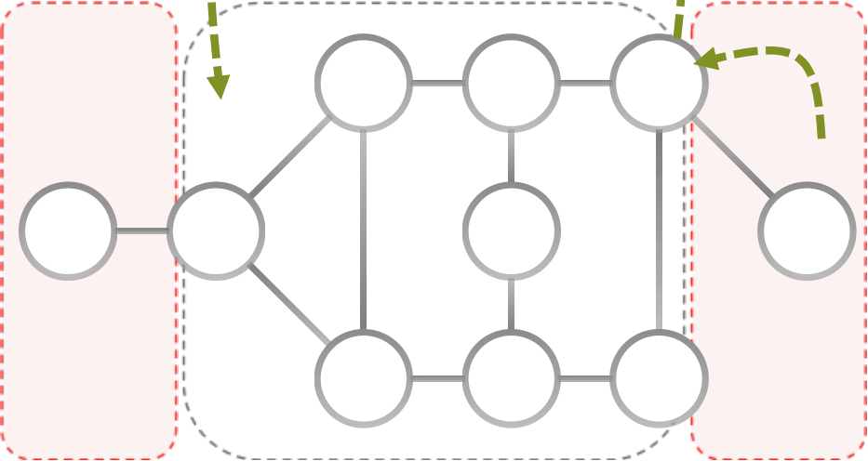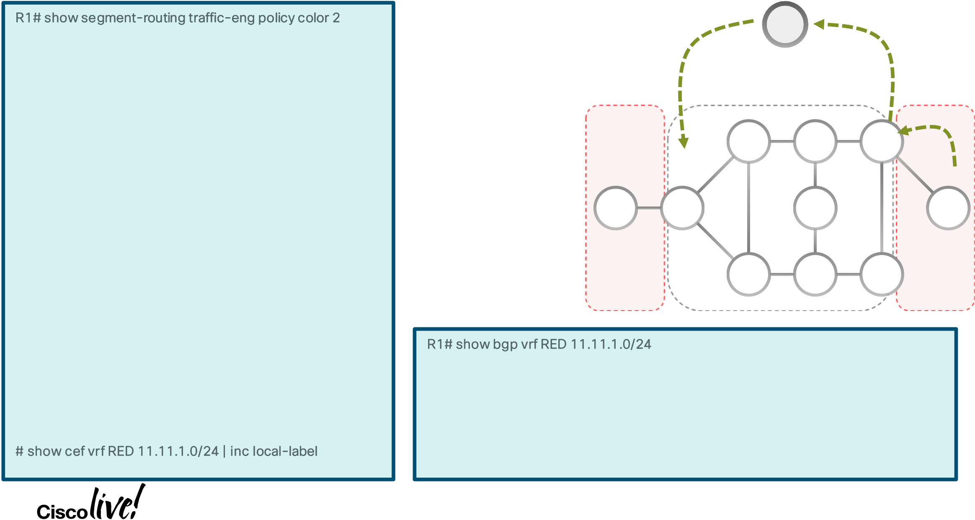

L3VPN Service Policy Work-flow and Steering

|  |  |  |  |
| --- | --- | --- | --- |
| R1# show segment-routing traffic-eng policy color 2 | ➌ BGP: 110/24 via PE5 | RR | ➋ BGP: 11.11.1.0/24 via |
| Color: 2, End-point: 1.1.1.5 |
| Name: srte_c_2_ep_1.1.1.5 |
| VPN-LABEL: 24016 | PE5 VPN-LABEL: 24016 |
| Status: |
| Low-Delay (color 2) | Low-Delay (color2) |
| Admin: up Operational: up for 00:39:14 (since Mar 31) |

Candidate-paths:

|  |  |  |  |  |
| --- | --- | --- | --- | --- |
| Preference: 200 (BGP ODN) (active) | ➍ PE2 check prefix | Vrf  RED | I:50 | ➊ BGP: 11.11.1.0/24 |
| Requested BSID: dynamic | via CE10 |
| PCC info: |
| from PE5 with Low- |
| Symbolic name: bgp_c_2_ep_1.1.1.5_discr_200 | 11.11.1.0/24 |
| latency (color 2) |
| PLSP-ID: 2 |
| Dynamic (valid) | ➎ Initiate SRTE policy | D:15 |
| Metric Type: LATENCY, Path Accumulated Metric: 10 |
| use template color 2 |
| 16005 [Prefix-SID, 1.1.1.5] |
| Vrf  RED |
| Preference: 100 (BGP ODN) |
| ➏ Policy → SID-list |
| Requested BSID: dynamic |
| PCC info: | <16005> BSID 24031 |
| Symbolic name: bgp_c_2_ep_1.1.1.5_discr_100 |
| PLSP-ID: 1 |

Dynamic

|  |  |  |  |  |
| --- | --- | --- | --- | --- |
| Metric Type: NONE, Path Accumulated Metric: 0 | R1# show bgp vrf RED 11.11.1.0/24 | | | 25 |
| Attributes: |
| Paths: (1 available, best #1) | | |
| Binding SID: 24031 | Local | | |
| Forward Class: 0 |
| 2.2.2.2 C:2 (bsid:24031) (metric 10) from 2.2.2.2 (2.2.2.2) | | |
| Steering BGP disabled: no | Received Label 24016 | | |
| IPv6 caps enable: yes | … | | |
| # show cef vrf RED 11.11.1.0/24 | inc local-label | Extended community: Color:2 RT:2:2 | | |
| SR policy color 2, up, registered, bsid 24031, if-handle 0x02000fe0 | | |
| via local-label 24031, 3 dependencies, recursive |
| Source AFI: VPNv4 Unicast, Source VRF: RED, Source Route Distinguisher: 2:2 | | |
| #CLUS | BRKMPL-2130 | © 2019 Cisco and/or its affiliates. All rights reserved. Cisco Public |

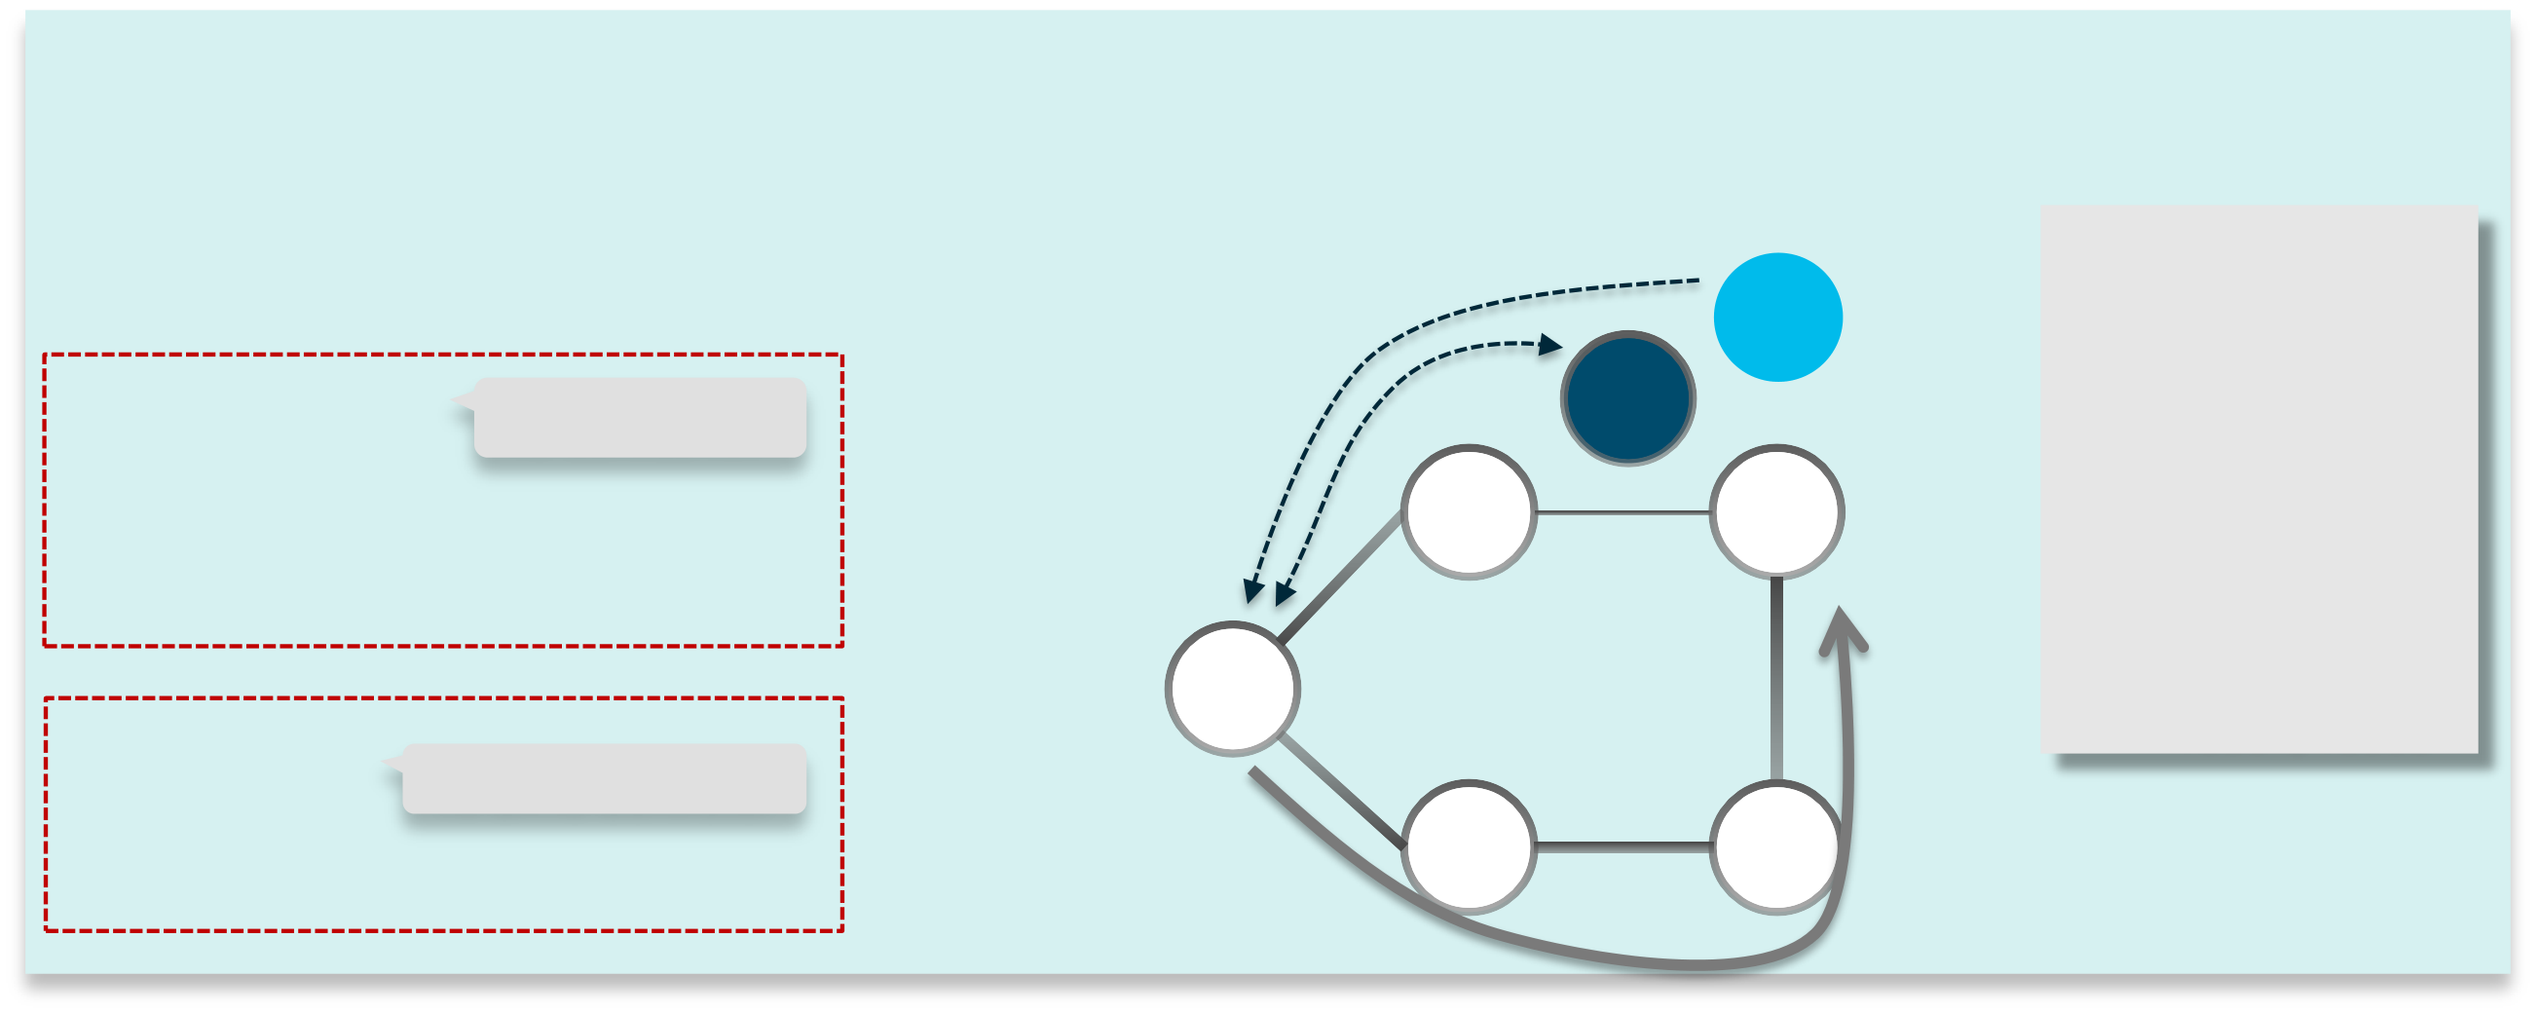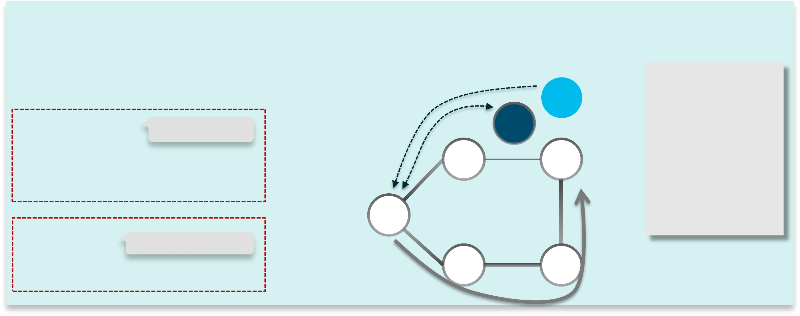

Use Case4: BGP SR-Policy Auto Initiated Policy

|  |  |  |  |  |  |  |  |  |  |  |
| --- | --- | --- | --- | --- | --- | --- | --- | --- | --- | --- |
| router bgp 1  bgp router-id 1.1.1.1  address-family ipv4 unicast address-family vpnv4 unicast address-family ipv4 sr-policy ! | | | New BGP SAFI “sr-policy” conveys SR-TE policy and NLRI information to signal a candidate paths from controller to | | | | | | | |
| headend | | | IPv4 – SR Policy | | | | |
| 1.1.1.10 | | | RR | Ctrl | 1.1.1.20 | | NLRI |
| Color 10 |
| neighbor 1.1.1.10 remote-as 1 | | To Service RR |
| End-point 1.1.1.3 |
| Distinguisher 2 |
| 1.1.1.1 | 1 | 2 | 3 | | | Tunnel encaps attr | |
| update-source Loopback0 address-family ipv4 unicast address-family vpnv4 unicast !  neighbor 1.1.1.20 | | |
| Preference 100 | |
| Binding SID 999 | |
| Segment List | |
| Weight: 1 | |
| <16004, 16003> | |
| remote-as 1 | To SRTE Controller | | 5 | | | 4 | | | | |
| update-source Loopback0 address-family ipv4 sr-policy | | |

curl http://1.1.1.1:8088/srpolicy-install -H "Content-Type: application/json" -X POST -d '{"source" : "1.1.1.1", "end-point" : "1.1.1.3",

"binding-sid" : 999 "color" : 10, "preference" : 100, "route-distinguisher" : 0, "path-list" : [{"label-stack" : [16400 16300], "metric_te" :

30, "type" : sr-te}]}'

|  |  |  |  |  |
| --- | --- | --- | --- | --- |
|  | #CLUS | BRKMPL-2130 | © 2019 Cisco and/or its affiliates. All rights reserved. Cisco Public | 26 |

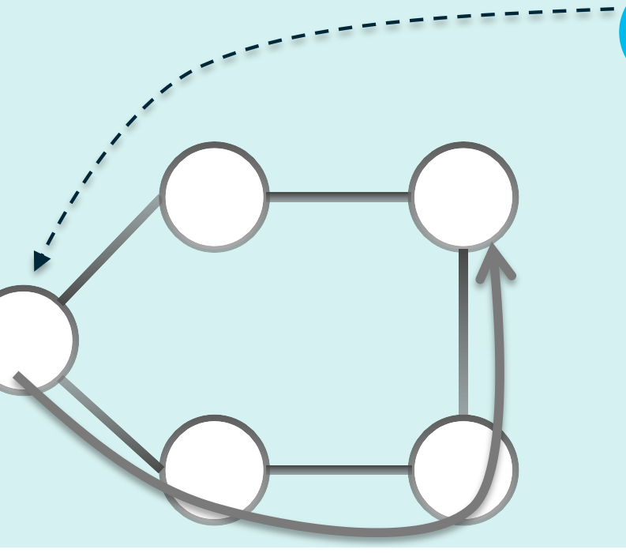

Controller Based NLRI Auto-Policy Steering

R1# show segment-routing traffic-eng policy   
SR-TE policy database  
---------------------  
Name: bgp_AP_1 (Color: 10, End-point: 1.1.1.3)   
 Status:   
 Admin: up Operational: up for 00:08:19 (since Jun 13 21:18:10.469) Candidate-paths:

|  |  |  |  |  |  |
| --- | --- | --- | --- | --- | --- |
| Preference 100: | | 1 | Ctrl | | 27 |
| Explicit: segment-list Autolist_3_1* (active) | |
| Weight: 1, Metric Type: IGP | |
| 16004 [Prefix-SID, 1.1.1.4] | IPv4 – SR Policy |
| 2 | 3 |
| 16003  Attributes:   Binding SID: 999 | NLRI  Color 10  End-point 1.1.1.3 Distinguisher 2 |
| Allocation mode: explicit | Tunnel encaps attr | 5 | 4 |
| State: Programmed | Preference 100 |
| Policy selected: yes Auto-policy info:   Creator: BGP | Binding SID 999  Segment List   Weight: 1   <16004, 16003> |
| #CLUS | | BRKMPL-2130 | © 2019 Cisco and/or its affiliates. All rights reserved. Cisco Public | |

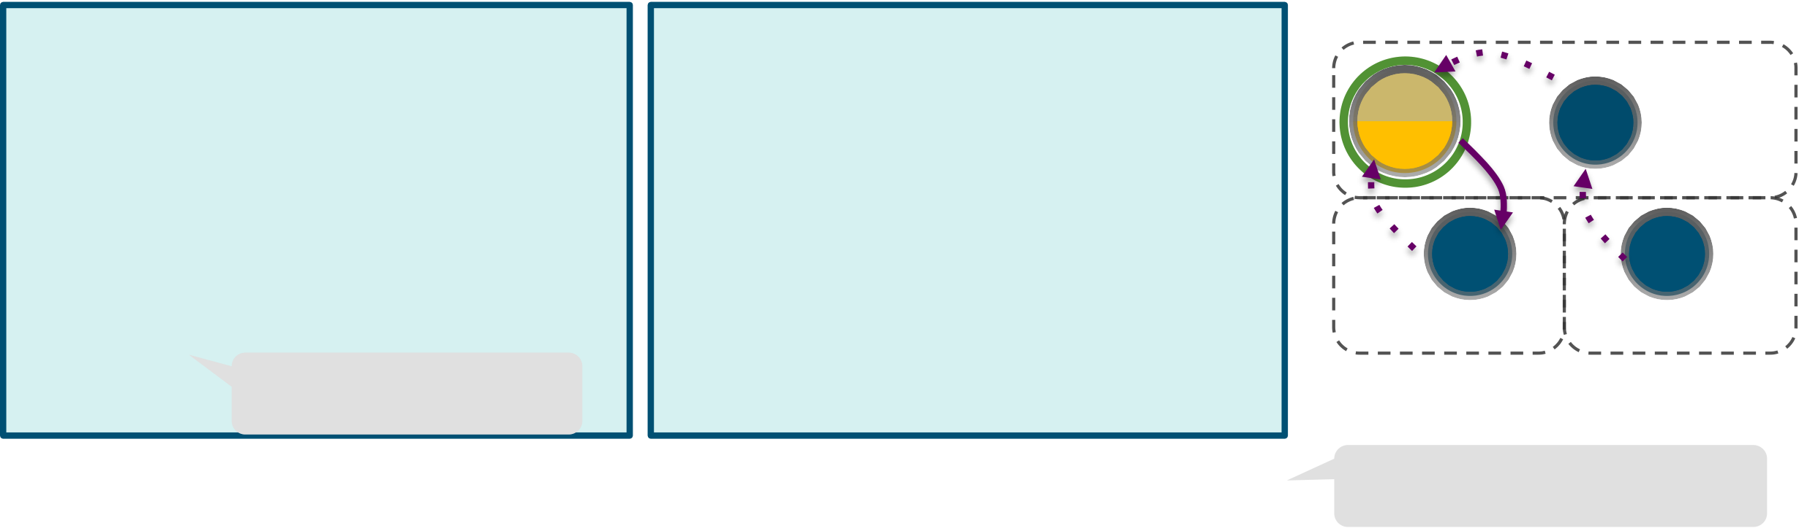

Use Case5: Controller Multi-domain SRTE Policy

• SR-PCE build inter-domain topology based on the SR-TE DB

❖ Learns an attached network domain topology via IGP or BGP-LS

❖ Learns a remote domain topology via BGP-LS, directly or through a Route Reflector

On SR-PCE: On PCC:

192.99.1.1

pce segment-routing traffic-eng pcc

address ipv4 192.99.1.1 source-address ipv4 1.1.1.1 Domain1

**SR-**

! pce address ipv4 192.99.1.1

**PCE**  **PCEP**  RR

router bgp 1 router isis 1 !! or ospf

address-family link-state link-state distribute link-state instance-id 101

1.1.1.1 1.1.1.3

neighbor 1.1.1.1 router bgp 101

**BGP-LS**  1 3

remote-as 101 address-family link-state link-state

address-family link-state link-state neighbor 192.99.1.1 Domain2 Domain3

**!**  BGP-LS: Collection of remote-as 1

ISIS / OSPF link state address-family link-state link-state

curl --raw -vN

PCEP used to deploy policy

"http://192.99.1.1:8080/lsp/create/simple?peer=1.1.1.1&name=rest_1_5&type=sr&

source=1.1.1.1&destination=1.1.1.3&color=10"

 #CLUS BRKMPL-2130 © 2019 Cisco and/or its affiliates. All rights reserved. Cisco Public 28

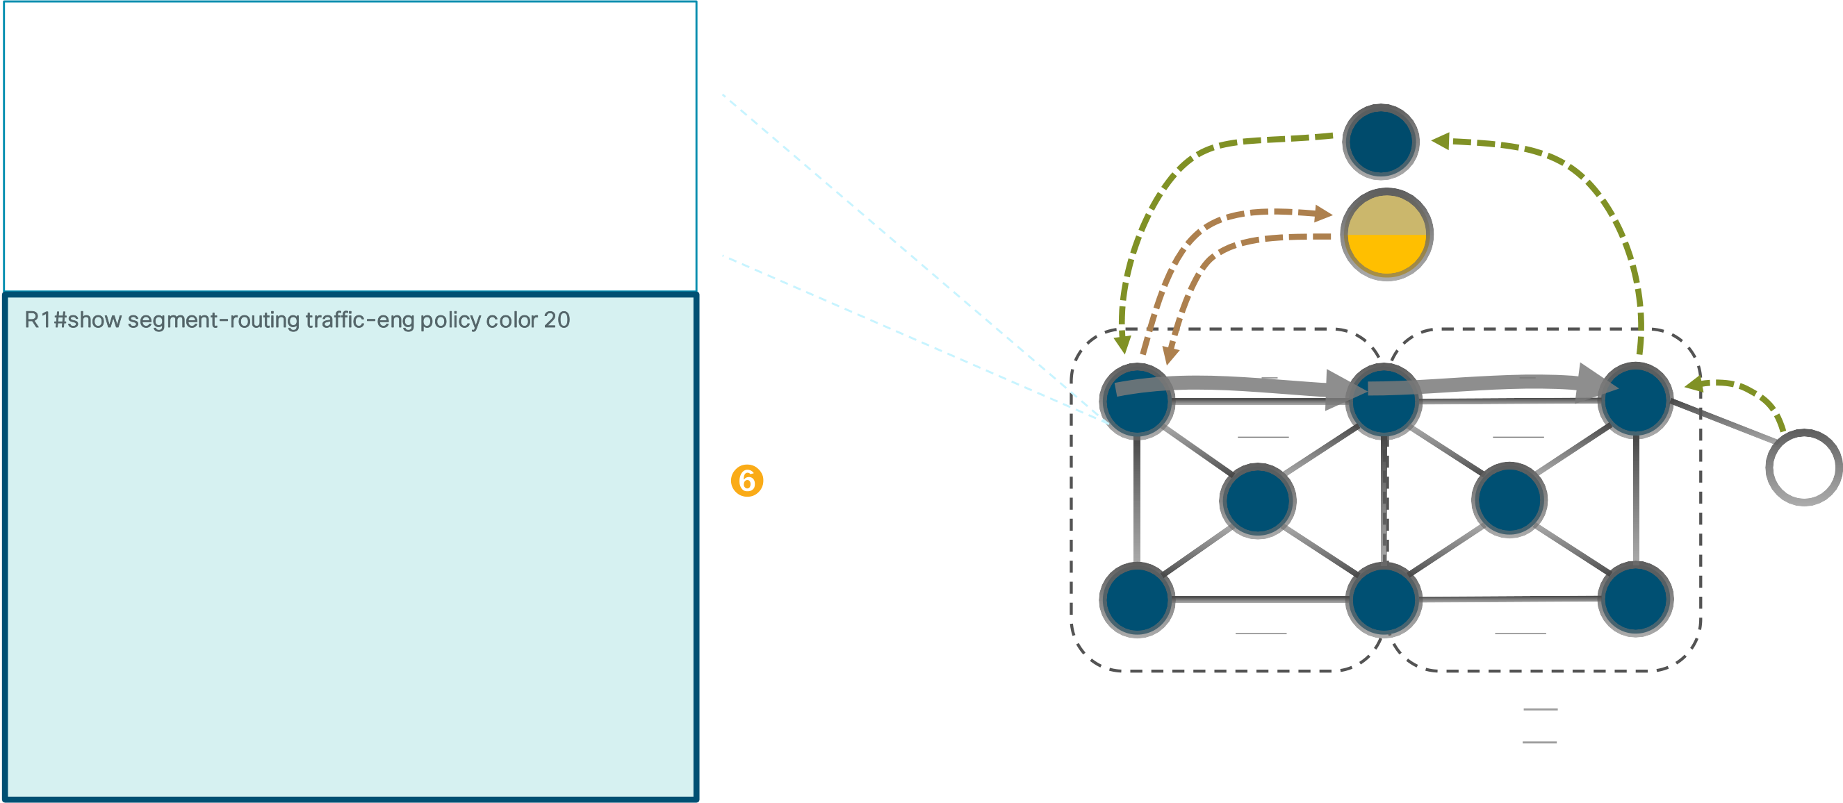

Centralized Inter-Domain SR-PCE Policy Steering

|  |  |  |  |  |  |  |
| --- | --- | --- | --- | --- | --- | --- |
| segment-routing | ➌ BGP: 11/8 via PE3 VPN- | | D:1 | ➋ BGP: 11/8 via PE3 | | |
| traffic-eng | VPN-LABEL: 24016 | | |
| LABEL: 24016 with | |
| policy pcep1 |
| metric latency (color 20) | | RR | metric latency (color 20) | |
| color 20 end-point ipv4 1.1.1.3 |
| candidate-paths |
| preference 200 | ➍ PE1 send PCE path | | **SR-** **PCE** | | ➊ BGP: |
| dynamic pcep |
| metric type latency |
| request via pecp base | |
| R1#show segment-routing traffic-eng policy color 20 | Lowest TE metric to PE3 | | 11/8 via CE |
| on color-template | |
| 2 | D:1 | 3 |
| Color: 20, End-point: 1.1.1.3 |
| Name: srte_c_20_ep_1.1.1.3 | ➎ PCE return path to PE3 & metric latency | 1 |
| Status: | I:100 | I:100 |
| Admin: up Operational: up for 00:00:05 (Apr 9 09:58:11) |
| Candidate-paths: | 5 | 4 | | CE  11/8 |
| ➏ PE1 initiate Policy: | |
| Preference: 200 (configuration) (active) (reoptimizing) |
| Name: pcep1 | B-SID 24022; Adj-SID | |
| Requested BSID: dynamic |
| PCC info: | <24004,24024> ➐ forward 11/8 | 6 | I:100 |
| 7 | I:100 | 8 |
| Symbolic name: cfg_pcep1_discr_200 |
| PLSP-ID: 4 |
| Dynamic (pce 192.99.1.1) (valid) | via BSID 24022 | |
| Metric Type: LATENCY, Path Accumulated Metric: 20 |

24004 [Adjacency-SID, 10.12.0.1 - 10.12.0.2] 24024 [Adjacency-SID, 10.23.1.2 - 10.23.1.2] Attributes:   
Binding SID: 24022

Default IGP link metric: I:10   
Default TE link metric: T:10

|  |  |  |  |  |
| --- | --- | --- | --- | --- |
|  | #CLUS | BRKMPL-2130 | © 2019 Cisco and/or its affiliates. All rights reserved. Cisco Public | 29 |

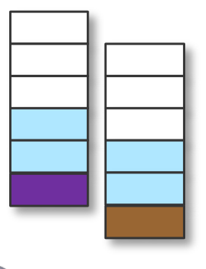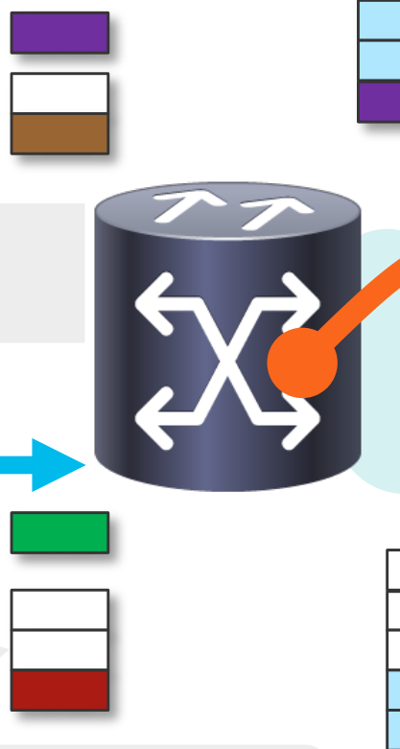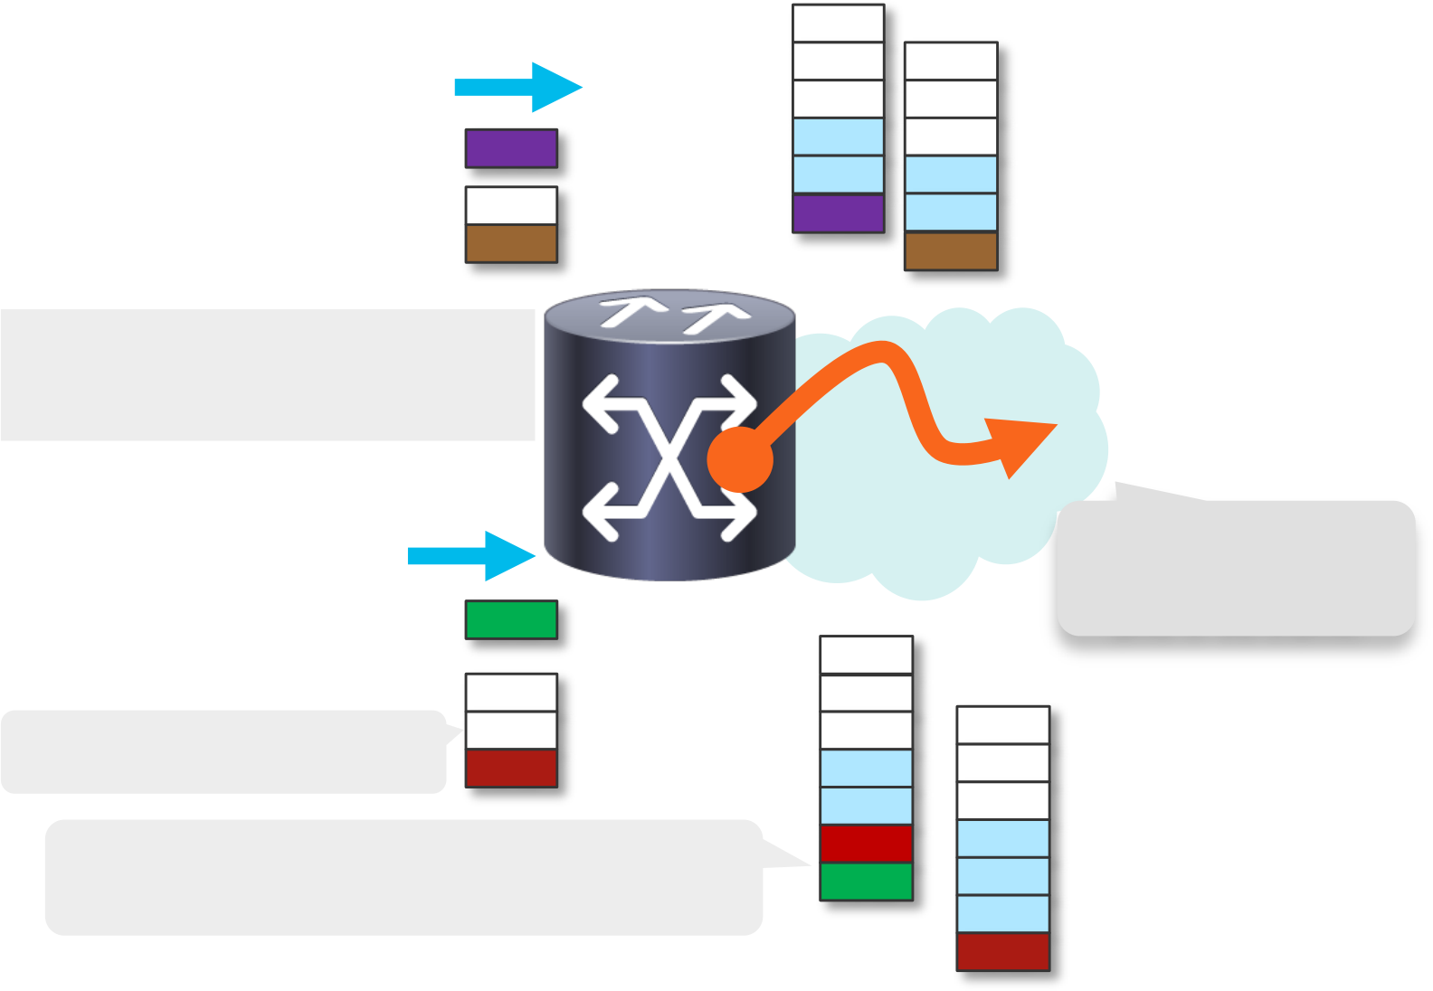

Use Case6: Color-only Null-end Policy

16001• Single SR policy per color 16002 16003 16001 16002 Color-only and IPv6 enabled IPv4   
 16005 16004 16004 16003

BSID IPv4 16005Address Family Agnostic IPv4 IPv4

End-point: 0.0.0.0, color: 10  
• SR policy carries: Binding SID: 99999, Segment-  
 list: {16200,16300}  
 Labeled v4, Unlabeled v4 Policy P1

A SINGLE policy Labeled v6, Source expected carries both IPv4

IPv6 and IPv6 traffic to add v6-exp-null 16001   
 BSID 16002  
Unlabeled v6, HE performs Labeled IPv6 traffic includes IPv6 exp-null IPv6 2 16003 16004 16001 16002   
 automatic v6-exp-null label HE automatically imposes IPv6 exp-null 16005 2 16003 16004   
 push for unlabeled v6 traffic label for unlabeled IPv6 traffic steered onto the policy IPv6 16005 2   
 IPv6

 #CLUS BRKMPL-2130 © 2019 Cisco and/or its affiliates. All rights reserved. Cisco Public 30

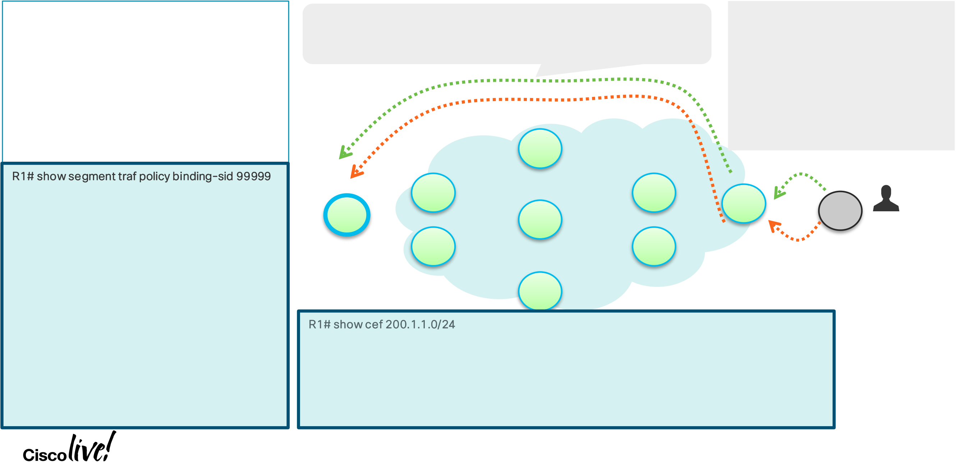

Color-only & AF-agnostic Steering

|  |  |  |
| --- | --- | --- |
| segment-routing | When ”co-flag" set to 01, BGP prefix steering first match | extcommunity-set opaque color99 |
| traffic-eng | 99 co-flag 01 |
| SR-TE policy color and endpoint. Otherwise, prefix color- |
| policy c99-null-v4 | end-set |
| only match going steer over a null-end Policy (C, null). |
| binding-sid mpls 999 | ! |
| color 99 end-point ipv4 0.0.0.0 | BGP IPv4 unicast NLRI: 100.1.1.1/32 |
| ipv6 enable | NH: 1.1.1.E1, Color 99, Flags = 01 |

candidate-paths preference 111   
 explicit segment-list SL-2-via-1   
segment-list name SL-2-via-1

BGP IPv4 unicast NLRI: 200.1.1.0/24   
NH: 1.1.1.E2, Color 99, Flags = 01   
BGP IPv6 unicast NLRI: 200:1:1::1/128

|  |  |  |  |  |  |  |  |
| --- | --- | --- | --- | --- | --- | --- | --- |
| index 20 mpls label 16200 | **A** | **B1** | **C1** | **D1** | NH: 1.1.1.E1, Color 99, Flags = 01 | | |
| index 30 mpls label 16300 | **1.1.1.E1** | | 100.1.1.1/32  200.1.1.1/32 |
| R1# show segment traf policy binding-sid 99999 |
| Color: 99, End-point: 0.0.0.0 |
| **E1** | **1.1.1.E2** | **Z** |
| Name: srte_c_99_ep_0.0.0.0 | **C2** |
| Status: |
| **B2** | **D2** |
| Admin: up Operational: up for 00:04:40 (since |
| Apr 9 18:59:37.047) | 200:1:1::1/128 | | |
| Candidate-paths: |

Preference: 111 (configuration) (active)

|  |  |  |  |  |
| --- | --- | --- | --- | --- |
| Name: c99-null-v4 | **C3** | | | 31 |
| Requested BSID: 99999 |
| Explicit: segment-list SL-2-via-1 (valid) | R1# show cef 200.1.1.0/24 | | |
| Weight: 1, Metric Type: TE |
| 16200 [Prefix-SID, 2.2.2.2] | 10.16.3.0/24, version 218468, internal 0x5000001 0x0 (ptr 0x784a1df8) [1], 0x0 (0x0), 0x0 (0x0) | | |
| 16300 | Updated Apr 10 08:18:57.113 | | |
| Prefix Len 24, traffic index 0, precedence n/a, priority 4 | | |
| Attributes: |
| Binding SID: 999 | via local-label 99999, 3 dependencies, recursive [flags 0x6000] | | |
| Forward Class: 0 | path-idx 0 NHID 0x0 [0x78fbe2b8 0x0] | | |
| Steering BGP disabled: no | recursion-via-label | | |
| IPv6 caps enable: yes | next hop via 999/1/21 | | |
| #CLUS | BRKMPL-2130 | © 2019 Cisco and/or its affiliates. All rights reserved. Cisco Public |

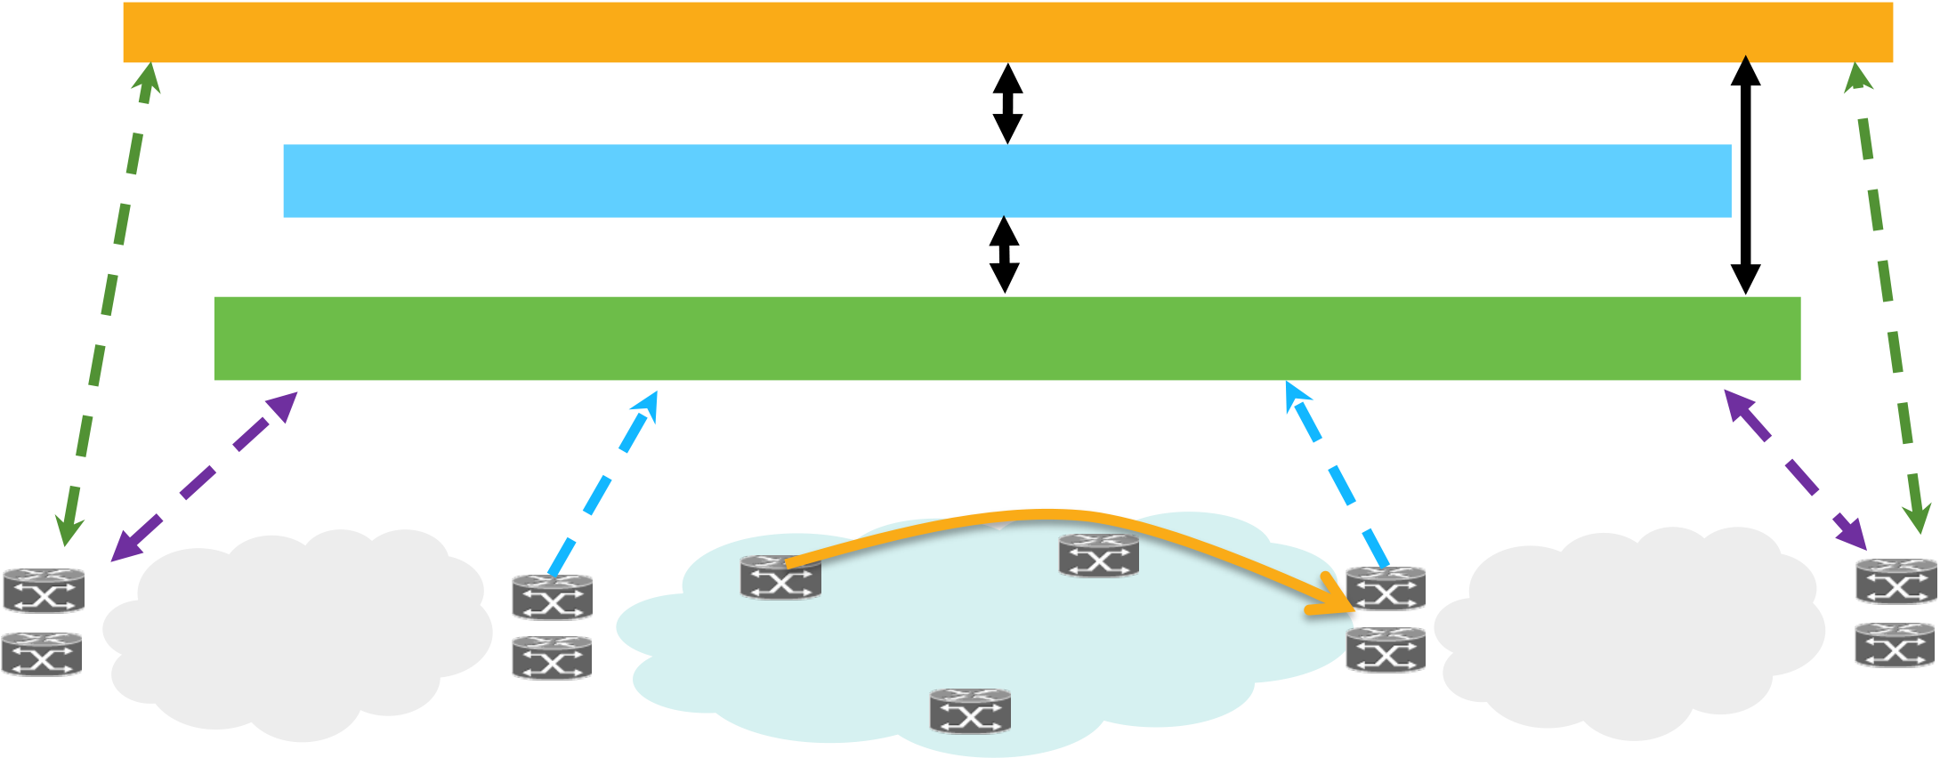

Evolved Network to Unified SR Fabric NSO Service Provisioning   
 API

Crosswork Optimization-Path Optimization with SLAs API

API

|  |  |  |  |  |  |
| --- | --- | --- | --- | --- | --- |
| Netconf/Yang | Segment-routing Path Compute Element (SR-PCE) | | | | Netconf/Yang |
| PCEP | BGP-LS | BGP-LS | PCEP |

Core Network

|  |  |  |  |  |
| --- | --- | --- | --- | --- |
| Edge  Node | AGG  Node | AGG  Node | Edge  Node | 32 |
| Core Network (existing RSVP-TE) | Regional Network 2 |
| Regional Network 1 |
| Services: BGP    Transport: Segment-Routing - MPLS  #CLUS BRKMPL-2130 © 2019 Cisco and/or its affiliates. All rights reserved. Cisco Public | | | |



RSVP-TE Bandwidth Accounting SR Accounting & RSVP resvBW Refresh

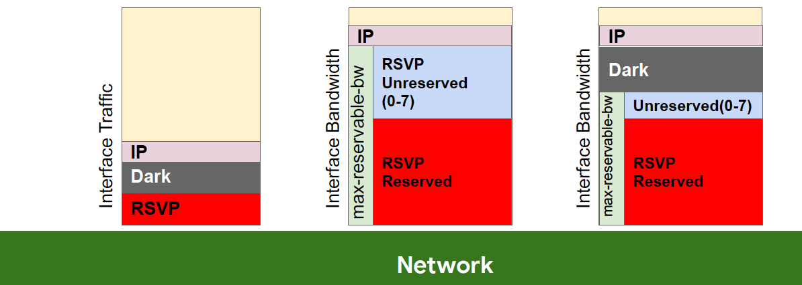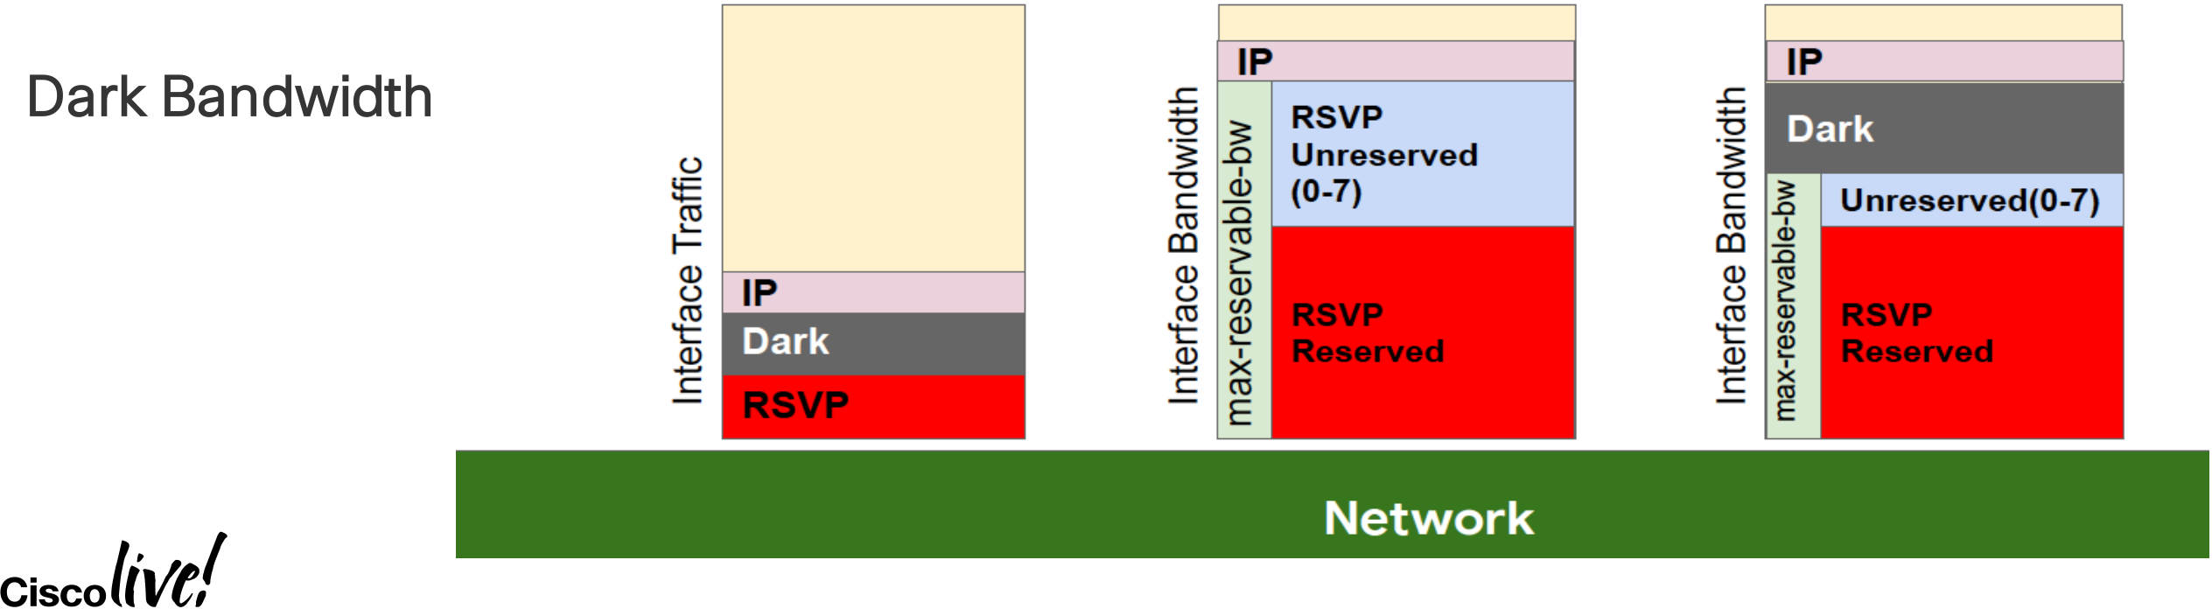

RSVP-TE AdmissionCtrl Aware of SR Accounting

• RSVP-TE non-zero Bandwidth

❖ Web/OTT customers: full-mesh rsvp-te + auto-BW

❖ Voice/Video Service Providers: full-mesh rsvp-te + auto-BW (or signalled-BW)

• SR-TE and RSVP-TE Coexistence

❖ One of Web/OTT customer introduced the network migration base on RSVP-TE Bandwidth Accounting at MPLS World Congress

Dark Bandwidth

• SR traffic can alter RSVP   
Maximum-Reservable-  
Bandwidth

• Recommended in SR,   
 RSVP-TE coexistence   
 scenarios

|  |  |  |  |
| --- | --- | --- | --- |
| #CLUS | BRKMPL-2130 | © 2019 Cisco and/or its affiliates. All rights reserved. Cisco Public | 34 |

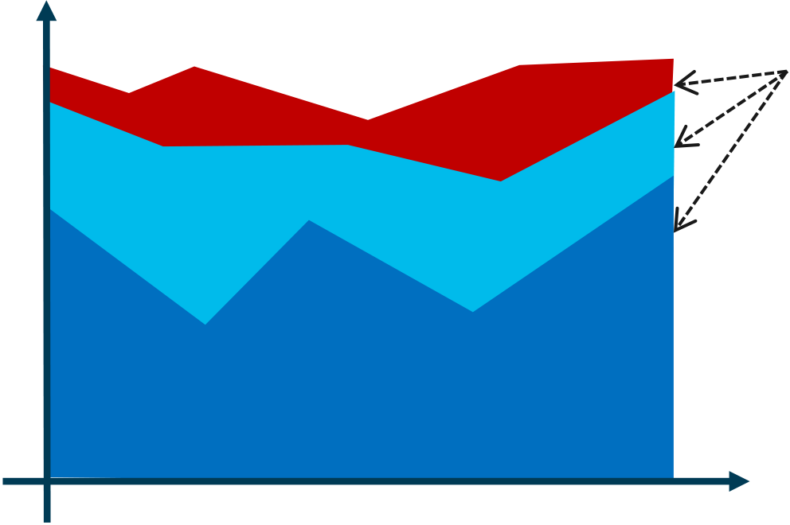

SR Accounting vs RSVP-TE “Dark Bandwidth”

Link BW

|  |  |  |
| --- | --- | --- |
| • Subset of the traffic that is not explicitly | Utilization | DARKBW |
| admission controlled by RSVP-TE |

• Those traffic bandwidth isn’t considered during RSVP-TE path computation as well as admission control

• It is assumed that SR traffic has higher priority than any other traffic transport

|  |  |  |  |  |  |
| --- | --- | --- | --- | --- | --- |
| with distributed RSVP-TE LSPs | | Time | | | 35 |
| • SR-accounting on RSVP links to trigger | |  | Interface BW from “Other” MPLS traffic | |
| ResvBW refresh and gradually reduce | |  | Interface BW from SR MPLS LSP traffic | |
|  | Interface BW from RSVP-TE MPLS LSP traffic | |
| the RSVP-TE bandwidth pool | |
|  | #CLUS | BRKMPL-2130 | | © 2019 Cisco and/or its affiliates. All rights reserved. Cisco Public |

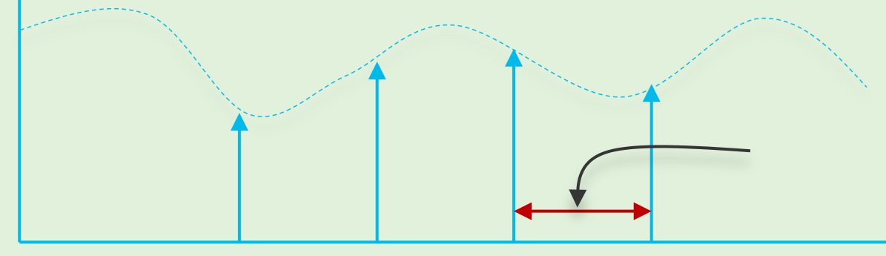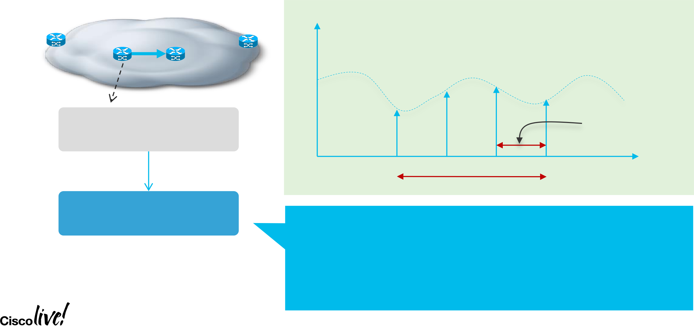

Dark Bandwidth Measurement

|  |  |  |  |  |  |
| --- | --- | --- | --- | --- | --- |
| Headend | A | B | Tailend | BDARK | Sample interval |
| SR Traffic Link | |

Utilization Collection

|  |  |  |  |  |  |  |
| --- | --- | --- | --- | --- | --- | --- |
| BDARK & “effective” | • | Application interval | | | Time | |
| BDARK @ application interval | | | | |
| resvBW Calculation |
| • | ❖ | An average of BDARK[t] samples is calculated | | | |
| ❖ | Configured Maximum Reservable-Bandwidth (BMRc) | | | |
| ❖ | “effective” resvBW flooded if change exceed threshold | | | |
| BDARK samples & “effective” resvBW (BMRe) calculated: | | | | |
| ❖ | BDARK[t]= SR_IPv4 + SR_IPv6 + SR_MPLS | | | |
| ❖ | resvBW[t]= BMRc - BDARK[t] | | | |
| #CLUS | BRKMPL-2130 | © 2019 Cisco and/or its affiliates. All rights reserved. Cisco Public | | 36 |

RSVP-TE resvBW and Flooding Threshold

• RSVP-TE resvBW Counters:  
❖ BMRc = Configured Maximum Reservable Link Bandwidth BMRe = Effective BMR  
❖ BMRef= last flooded BMRe

• “Effective” BMR (BMRe) collection @ application time [t]:  
 ❖ BMRe[t] = BMRc – BDARK[t] * K (K is a configurable adjustment-factor)

• Implementation provides BMRe flooding threshold as: BMRe changes as a percentage of “last flooded BMRe” (BMRef) Calculated as: |BMRe −BMRef|   
 BMRef

|  |  |  |  |  |
| --- | --- | --- | --- | --- |
|  | #CLUS | BRKMPL-2130 | © 2019 Cisco and/or its affiliates. All rights reserved. Cisco Public | 37 |

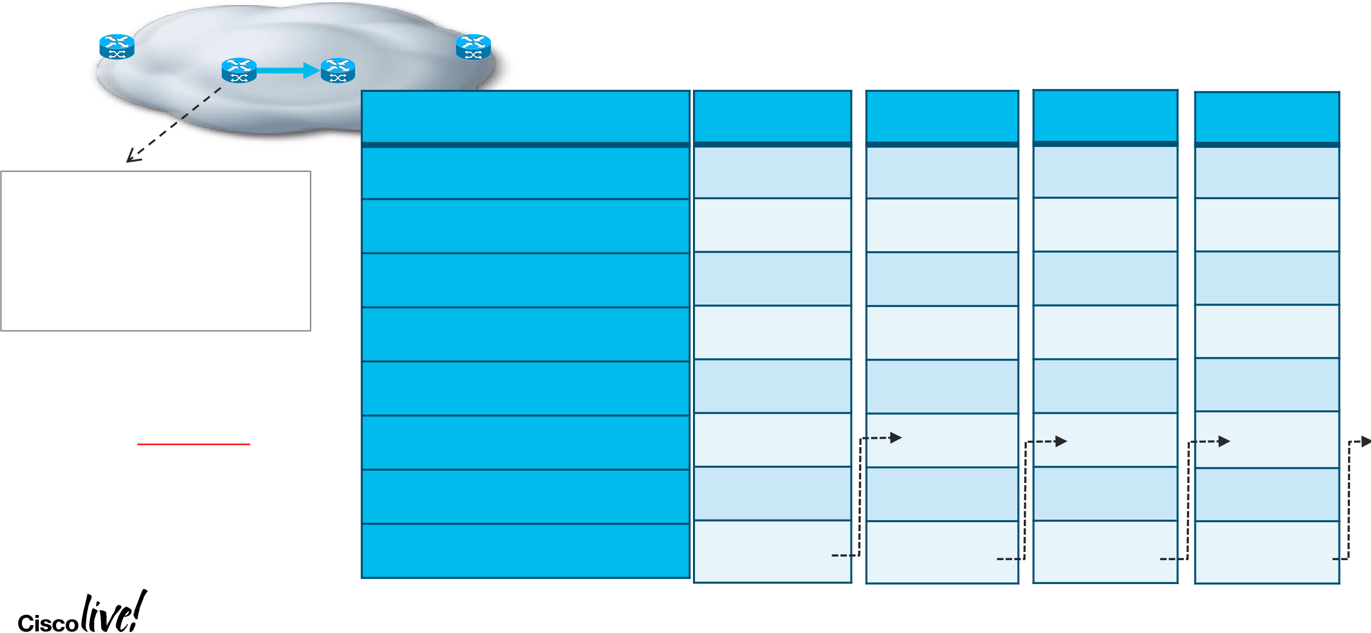

Solution Overview – Flooding Action By Timeframe

|  |  |  |  |  |  |  |  |  |  |  |  |
| --- | --- | --- | --- | --- | --- | --- | --- | --- | --- | --- | --- |
| Headend | A | B | Tailend | → | **T1** | → | **T2** | → | **T3** | → | **T4** |
| **App. Interval** |
| Interface TenGigE0/0/1/0 | | **BRSVP** – RSVP utilized link BW | 200 | 200 | 200 | 200 |
| Physical BW | = 1,000 | **BDARK** – SR utilized link BW | → | 0 | ↗ | 100 | ↘ | 40 | ↗ | 550 |
| BMRc | = 900 |
| Adjustment factor | = 100% |
| **BUTIL** – Total utilized link BW | → | 200 | ↗ | 300 | 240 | ↗ | 750 |
| ↘ |
| Flooding thr. Up | = 10% |
| **BResvd** – Total reserved link BW | 300 | 300 | 300 | 300 |
| Flooding thr. Down | = 10% |
| [1] 𝐵𝐷𝐴𝑅𝐾 = 𝐴𝑣𝑔 𝑆𝑅 𝑆𝑎𝑚𝑝𝑙𝑒𝑠 | | 900 | 800 | 860 | 350 |
| BMRe – Effec. max reservable link BW |

[2] 𝑩𝑴𝑹𝒆 = 𝑩𝑴𝑹𝒄 − 𝑩𝑫𝑨𝑹𝑲

|  |  |  |  |  |  |  |  |  |  |
| --- | --- | --- | --- | --- | --- | --- | --- | --- | --- |
| [3] *∆BMRe =* | |𝐵𝑀𝑅𝑒 −𝐵𝑀𝑅𝑒𝑓| 𝐵𝑀𝑅𝑒𝑓 | BMRef – Last flooded BMRe | #CLUS | 9004 | 900 | 800 | 800 | | |
| [4] Assumes BMRef of 900 from T0 | | ∆BMRe3– Change of BMRe | 0 | 11.11%[5] | 7.5% [6] | 56.2% [7] | | |
| [5] (|800 – 900|) / 900 | |
| [6] (|860 – 800|) / 800 | | **Action** | No Flooding | Flooding | No Flooding | Flooding | | |
| [7] (|350 – 800|) / 800 | |
| BMRef= 900 | BMRef= 800 | BMRef= 800 | | BMRef= 350 | |
| BRKMPL-2130 | © 2019 Cisco and/or its affiliates. All rights reserved. Cisco Public | | | | 38 |

Migration Solution Building Blocks

|  |  |  |  |  |  |  |  |  |  |  |  |
| --- | --- | --- | --- | --- | --- | --- | --- | --- | --- | --- | --- |
|  | |  | | --- | | **SR MPLS** | |  | |  | | --- | | **Auto-Steering** | |  | |  | | --- | | **Dark Bandwidth** | | |  | | --- | | **SR Traffic Engineering** | | |
| • | **Source-routing** | • | **Steer SR traffic away** | • | **Co-existence of non-zero** | • | **Simple, Automated and** |
| • | **Architecture brings right** | **from RSVP-TE LSP by** | • | **bandwidth RSVP tunnels** | **Scalable** | |
| **IGP sr-prefer, BGP** | **and SR in the same** |
| • | **No core state – state in** |
| **balance of distributed** |
| **color / endpoint match,** | **network domain** |
| **intelligence and** | **the packet header** | |
| **and binding SID install** |
| **Measure link utilization** |
| **centralized optimization** |
| • | • | **No tunnel interface – “SR** |
| **due to SR MPLS** |
| **Lightweight extensions** |
| **Policy”** | |
| • | **to IP control-plane** | • | **Adjust Maximum Link** | • | **BGP ODN candidate path** |
| **ResvBW (BMR) according** |
| **Leverages MPLS data** |
| **to SR accounting** | • | **Explicit local configured** |
| **and control plane** |
| **candidate paths** | |
| • | **Automate traffic steering** |
| • | **Color-only match and** |

**AF- agnostic automated**

**steering**

|  |  |  |  |  |
| --- | --- | --- | --- | --- |
|  | #CLUS | BRKMPL-2130 | © 2019 Cisco and/or its affiliates. All rights reserved. Cisco Public | 39 |

RSVP-TE Bandwidth Accounting Provision

• BMRe[t] = BMRc – BDARK[t] * K, where:

❖ K is a customer configurable adjustment-factor (0% to 200%)

❖ K decide how aggressively react to RSVP-TE effective resvBW adjustment

❖ resvBW refresh like “make before break”, gradually reduce the RSVP-TE bandwidth pool

accounting interfaces   
 segment-routing mpls   
 ipv4   
 ipv6   
!

mpls traffic-eng   
bandwidth-accounting   
 application   
 enforced   
 interval 90   
 sampling-interval 10 K = 150%; by default K = 100%   
 adjustment-factor 150   
 flooding threshold up 10 down 10

|  |  |  |  |  |
| --- | --- | --- | --- | --- |
|  | #CLUS | BRKMPL-2130 | © 2019 Cisco and/or its affiliates. All rights reserved. Cisco Public | 40 |



SR Accounting Statistics   
**R1# show mpls traffic-eng link-management interfaces Gi0/1/1/0 detail**  Bandwidth Utilization Details:

Sampling Interval : 10 sec

System Information:: Application Interval : 90 sec

Links Count : 16 (Maximum Links Supported 800) Link ID:: GigabitEthernet0/1/1/0 (10.12.110.1)

Adjustment Factor : 150%   
Max Reservable BW Up Threshold : 10   
Max Reservable BW Down Threshold: 10

Local Intf ID: 22 Last Application at: 19:41:14 Sun 30 Apr 2017 (51 seconds ago)

Link Status: Segment-Routing BW Utilization : 185346 kbits/sec

Adjusted BW Utilization : 278019 kbits/sec

Link Label Type : PSC   
Physical BW : 1000000 kbits/sec   
BCID : RDM   
Max Reservable BW : 621981 kbits/sec (reserved: 94% in, 94% out) Flooded Max Reservable BW: 621981 kbits/sec

Enforced BW Utilization : 278019 kbits/sec   
Next Application at: 19:42:43 Sun 30 Apr 2017 (in 38 seconds) Last Collection at : 19:40:42 Sun 30 Apr 2017 (13 seconds ago) Next Collection at : 19:40:51 Sun 30 Apr 2017 (in 6 seconds)

|  |  |  |
| --- | --- | --- |
| BC0 (Res. Global BW) : 529309 kbits/sec (reserved: 94% in, 94% out) | Bandwidth Samples (Kbps): | Segment-Routing |
| BC1 (Res. Sub BW) : 0 kbits/sec (reserved: 100% in, 100% out) | Timestamp |

MPLS TE Link State : MPLS TE on, RSVP on, admin-up IGP Neighbor Count : 1   
Max Res BW (RDM) : 900000 kbits/sec   
BC0 (RDM) : 900000 kbits/sec

19:40:12 Sun 30 Apr 2017 187961 19:40:22 Sun 30 Apr 2017 180130 19:40:32 Sun 30 Apr 2017 187949 19:40:42 Sun 30 Apr 2017 180124

BC1 (RDM) : 0 kbits/sec Attributes : 0x0

Max Res BW (MAM) : 0 kbits/sec Ext Admin Group :

BC0 (MAM) : 0 kbits/sec Length : 256 bits

BC1 (MAM) : 0 kbits/sec Value : 0x::

Attribute Names :

Bandwidth Accounting: Segment-Routing Flooding Status: (1 area)

Bandwidth Accounting Enforced: Yes (output continues on the right side)

IGP Area[1]: IS-IS 0 level 2, flooded   
Nbr: ID 0000.0000.0002.00, IP 10.12.110.2 (Up)   
Admin weight: not set (TE), 10 (IGP)

|  |  |  |  |  |
| --- | --- | --- | --- | --- |
| * ResvBW = BMRc-BMRe = 621981 | #CLUS | Lockout Status: Never | © 2019 Cisco and/or its affiliates. All rights reserved. Cisco Public | 41 |
| BRKMPL-2130 |



SR Accounting & RSVP resvBW Refresh Monitoring

**R1# show mpls traffic-eng link-management summary**

System Information::   
Links Count : 16 (Maximum Links Supported 800) Flooding System : enabled   
IGP Areas Count : 1

IGP Areas   
----------

IGP Area[1]:: IS-IS 0 level 2   
Flooding Protocol : IS-IS   
Flooding Status : flooded   
Periodic Flooding : enabled (every 180 seconds) Flooded Links : 7   
IGP System ID : 0000.0000.0001   
MPLS TE Router ID : 1.1.1.1   
IGP Neighbors : 7

Bandwidth accounting:   
Sampling interval: 10 seconds, Next in 9 seconds Application interval: 90 seconds, Next in 1 seconds

SR accounting intervals when   
bandwidth-accounting enabled

|  |  |  |
| --- | --- | --- |
| **R1# show mpls traffic-eng link-management advertisements**  Flooding Status : Ready  Last Flooding : 470 seconds ago Last Flooding Trigger : Link BW changed Next Periodic Flooding In : 136 seconds   |  |  | | --- | --- | | Diff-Serv TE Mode : Not enabled Configured Areas : 1 | Effective BMRe triggers |   new resvBW flooding IGP Area[1]:: IS-IS 0 level 2   Flooding Protocol : IS-IS   IGP System ID : 0000.0000.0001   MPLS TE Router ID : 1.1.1.1   Flooded Links : 5  Link ID:: 0 (GigabitEthernet0/1/1/0)  Link IP Address : 10.12.110.1  O/G Intf ID : 22  Neighbor : ID 0000.0000.0002.00, IP 10.12.110.2 TE Metric : 10  IGP Metric : 10  Physical BW : 1000000 kbits/sec  BCID : RDM  Max Reservable BW : 621981 kbits/sec  Res Global BW : 899999 kbits/sec  Res Sub BW : 0 kbits/sec |

|  |  |  |  |
| --- | --- | --- | --- |
| #CLUS | BRKMPL-2130 | © 2019 Cisco and/or its affiliates. All rights reserved. Cisco Public | 42 |

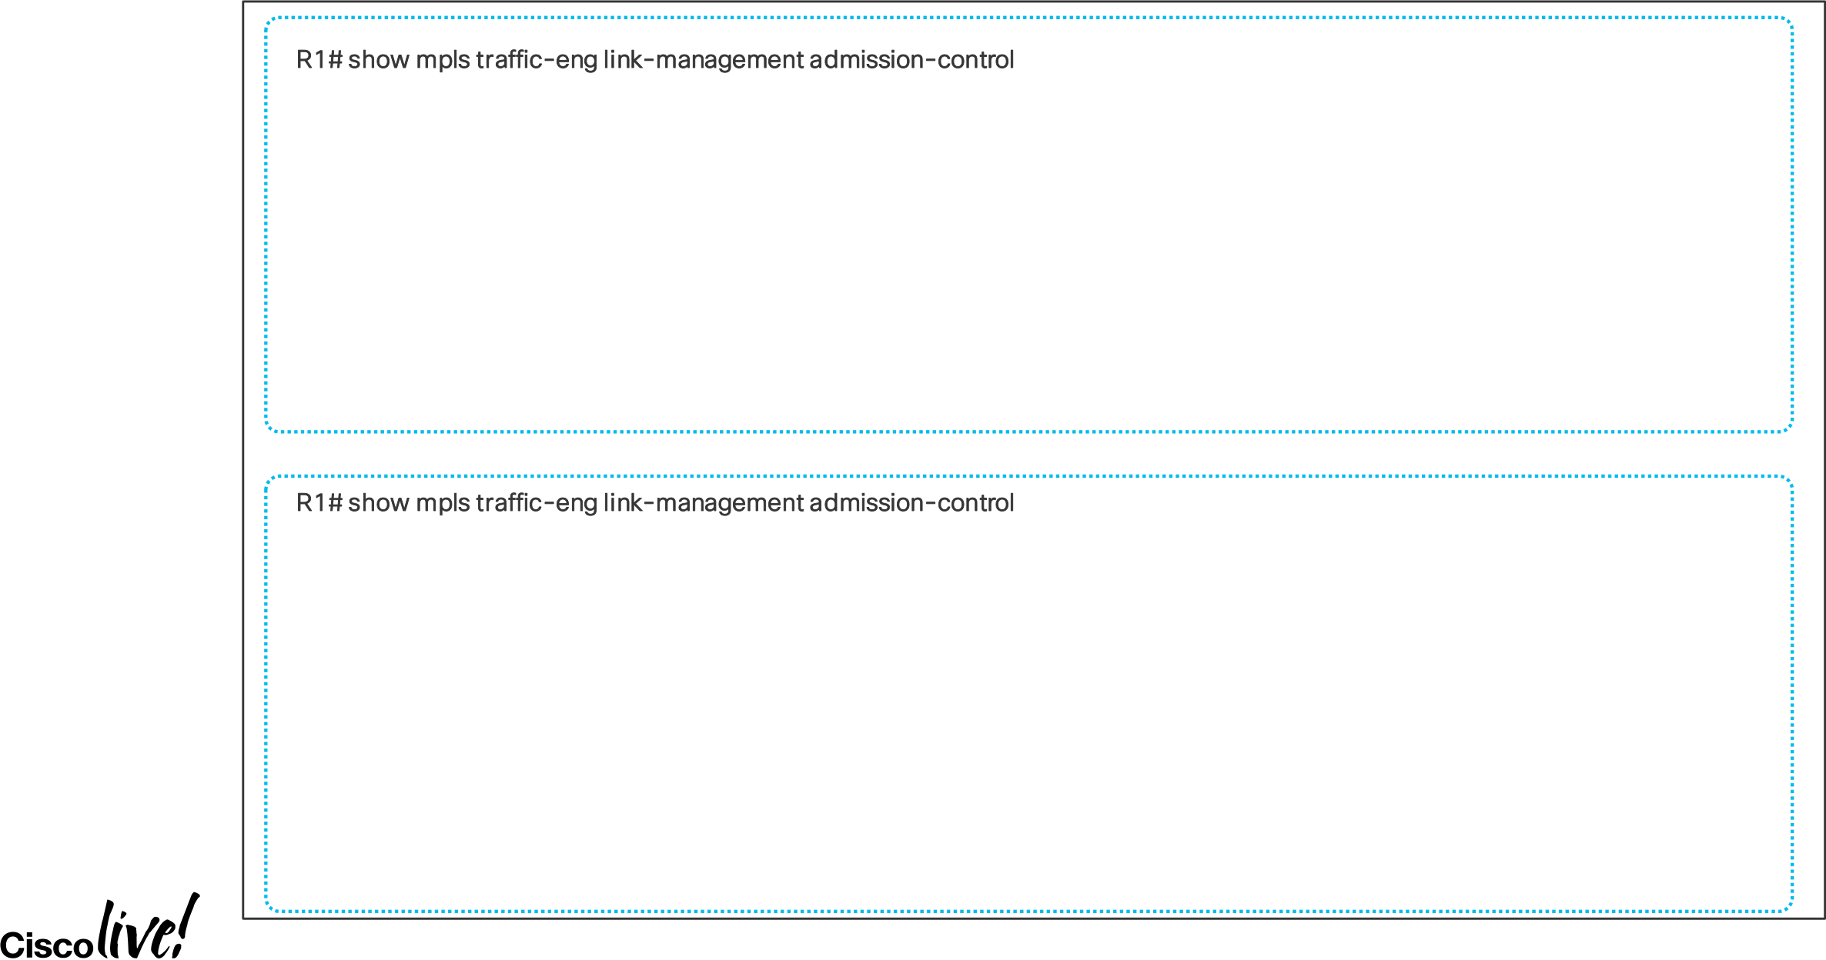

Tunnel Pre-emption When Not Enough ResvBW

R1# show mpls traffic-eng link-management admission-control   
 System Information::   
 Tunnels Count : 3   
 Tunnels Selected : 3   
Bandwidth descriptor legend:   
B0 = bw from pool 0, B1 = bw from pool 1, R = bw locked, H = bw held   
TUNNEL ID UP IF DOWN IF PRI STATE BW (kbits/sec)  
------------------------ ---------- ---------- --- ------------- ---------------

|  |  |  |  |  |
| --- | --- | --- | --- | --- |
| 1.1.1.1 10_6 | - | Gi0/1/1/0 | 3/3 Resv Admitted 0 | B0 |
| 1.1.1.1 10_7 | - | Te0/3/0/1 3/3 Resv Admitted 800000 | | RB0 |

RP/0/RSP0/CPU0:Apr 30 19:43:51.209 : te_control[1178]: %ROUTING-MPLS_TE-5-LSP_REOPT : tunnel-te10 (signalled-name: SRTE_RTR1_t10, old LSP Id: 6, new LSP Id: 7) has been reoptimized; reason: Soft Preemption.

R1# show mpls traffic-eng link-management admission-control   
 System Information::   
 Tunnels Count : 3   
 Tunnels Selected : 3   
Bandwidth descriptor legend:   
B0 = bw from pool 0, B1 = bw from pool 1, R = bw locked, H = bw held   
TUNNEL ID UP IF DOWN IF PRI STATE BW (kbits/sec)  
------------------------ ---------- ---------- --- ------------- ---------------1.1.1.1 10_3 - Gi0/1/1/0 1/1 Resv Admitted 800000 RB0

RP/0/RSP0/CPU0:Apr 30 19:29:08.551 : te_control[1178]: %ROUTING-MPLS_TE-5-LSP_UPDOWN : tunnel-te10 (signalled-name: SRTE_RTR1_t10, LSP Id: 3) state changed to down   
RP/0/RSP0/CPU0:Apr 30 19:29:25.131 : te_control[1178]: %ROUTING-MPLS_TE-5-LSP_UPDOWN : tunnel-te10 (signalled-name: SRTE_RTR1_t10, LSP Id: 4) state changed to up

|  |  |  |  |
| --- | --- | --- | --- |
| #CLUS | BRKMPL-2130 | © 2019 Cisco and/or its affiliates. All rights reserved. Cisco Public | 43 |



Use Case7: SRTE Policy with Bandwidth OnDemand

REST/YANG

|  |  |  |  |  |  |
| --- | --- | --- | --- | --- | --- |
| 1. | Operator configures SR-TE policy with | 5 | SR-PCE | network topology | |
| 2. | bandwidth constraint | 4 | |
| PCC sends PCReq to SR-PCE controller | Crosswork  Optimization | PCE |
| 3. | SR-PCE requests BW-path from Crosswork | 2 | 3 | |
| Optimization |
| 4. | BGP-LS / PCEP | |
| Crosswork Optimization returns BW-path (or |
| network topology | |
| no-path) to SR-PCE |
| 5. | SR-PCE sends BW-path (or no-path) to PCC | SNMP/Telemetry | |
| link traffic utilizations | |

1

|  |  |
| --- | --- |
| segment-routing   traffic-eng | **PCC** |

policy BW123   
bandwidth 888   
color 10 end-point ipv4 3.3.3.3   
candidate-paths

|  |  |  |  |  |  |
| --- | --- | --- | --- | --- | --- |
| preference 100 | CLI inter-domain policy | #CLUS | BRKMPL-2130 | © 2019 Cisco and/or its affiliates. All rights reserved. Cisco Public | 44 |
| dynamic pcep |
| path calculated by PCE |
|  |

BWoD Policy Configure and Show Output

|  |  |  |
| --- | --- | --- |
| segment-routing  traffic-eng   pcc   pce address ipv4 192.99.1.1 !  policy BW123  bandwidth 888  color 10 end-point ipv4 3.3.3.3 autoroute  !  candidate-paths   preference 100   dynamic pcep   metric   type te  ! |  | pcc# show segment-routing traffic-eng policy  SR-TE policy database --------------------- Name: BW123 (Color: 10, End-point: 3.3.3.3) ID: 1 Status:   Admin: up Operational: up for 2d19h (since Jan 27 18:10:16.545) Candidate-paths:   Preference 100:   Dynamic (pce 192.99.1.1) (active), valid yes   Weight: 0, Metric Type: TE   IGP area: 0   16300 [Prefix-SID, 3.3.3.3]   Attributes:   Binding SID: 25056   Allocation mode: dynamic   State: Programmed   Policy selected: yes   Forward Class: 0   Bandwidth Requested: 888 kbps   Bandwidth Current: 888 kbps |

|  |  |  |  |  |
| --- | --- | --- | --- | --- |
|  | #CLUS | BRKMPL-2130 | © 2019 Cisco and/or its affiliates. All rights reserved. Cisco Public | 45 |



Key Takeaways

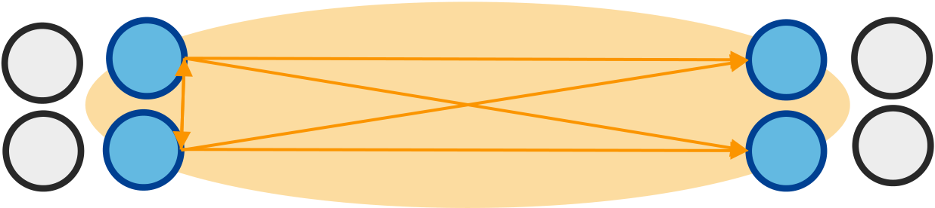

Migrate to Scalable and Programmable Network

L3VPN/EVPN (VPNv4/VPNv6)



L3VPN/EVPN (VPNv4/VPNv6)



|  |  |  |  |  |  |  |  |  |  |
| --- | --- | --- | --- | --- | --- | --- | --- | --- | --- |
| PE1 | P3 | RSVP-TE | P5 | PE7 | PE1 | P3 | SR/SR-TE | P5 | PE7 |
| PE2 | P4 | P6 | PE8 | PE2 | P4 | P6 | PE8 |

RSVP-TE  
❖ RSVP-TE Mesh for FRR  
❖ Config+State for N(N-1) Tunnels Traffic steering by IGP autoroute

Segment Routing  
❖ Automatic 100% FRR with TI-LFA Explicit/Dynamic Stateless Policy Traffic steering by policy B-SID

|  |  |  |  |  |
| --- | --- | --- | --- | --- |
|  | #CLUS | BRKMPL-2130 | © 2019 Cisco and/or its affiliates. All rights reserved. Cisco Public | 47 |



SR Unified Fabric Attributes

Seamless   
Deployment

On-Demand SR policy Inter & Automated Steering Domain

Stateless   
Service Chain Automated 50ms Protection

Enhanced   
OAM & PerfMon Micro-Loop   
 Avoidance

|  |  |  |  |  |
| --- | --- | --- | --- | --- |
|  | #CLUS | BRKMPL-2130 | © 2019 Cisco and/or its affiliates. All rights reserved. Cisco Public | 48 |

Stay Up-To-Date   
 <http://www.segment-routing.net/>

|  |  |
| --- | --- |
|  | <https://www.linkedin.com/groups/8266623> |

<https://twitter.com/SegmentRouting>

|  |  |  |  |  |  |
| --- | --- | --- | --- | --- | --- |
|  |  | <https://www.facebook.com/SegmentRouting/> | | | |
| [Segment Routing, Part I - Textbook](https://www.amazon.com/dp/B01I58LSUO/ref=cm_sw_su_dp) | | | | |
| #CLUS | | BRKMPL-2130 | © 2019 Cisco and/or its affiliates. All rights reserved. Cisco Public | 49 |



Complete your online session evaluation

• Please complete your session survey after each session. Your feedback is very important.

• Complete a minimum of 4 session surveys and the Overall Conference survey (starting on Thursday) to   
receive your Cisco Live water bottle.

• All surveys can be taken in the Cisco Live Mobile App or by logging in to the Session Catalog on [ciscolive.cisco.com/us](http://ciscolive.cisco.com/us).

Cisco Live sessions will be available for viewing on demand after the event at [ciscolive.cisco.com](https://ciscolive.cisco.com/).

|  |  |  |  |
| --- | --- | --- | --- |
| #CLUS | BRKMPL-2130 | © 2019 Cisco and/or its affiliates. All rights reserved. Cisco Public | 50 |



Continue your education

Demos in the   
Cisco campus

Meet the engineer   
1:1 meetings

Walk-in labs

Related sessions

|  |  |  |  |  |
| --- | --- | --- | --- | --- |
|  | #CLUS | BRKMPL-2130 | © 2019 Cisco and/or its affiliates. All rights reserved. Cisco Public | 51 |



Thank you

#CLUS



#CLUS

Acronym

|  |  |  |  |  |  |
| --- | --- | --- | --- | --- | --- |
| • | SR-TE | Segment Routing Traffic Engineering | | | 54 |
| • | RSVP-TE | Resource Reservation Protocol Traffic Engineering | | |
| • | TI-LFA | Path Protection with Topology Independent Loop Free Alternative | | |
| • | RESTAPI | An application program interface (API) that uses HTTP requests to GET, PUT, POST and DELETE data. | | |
| • | node-SID | A special type of prefix SID with node flag that identifies a specific node. | | |
| • | adjacency SID | A dynamically allocated segment SID on an interface | | |
| • | BSID | Binding SID used to identify an active candidate path of a policy | | |
| • | PCE | Path Computation Element | | |
| • | PCC | Path Computation Client | | |
| • | NLRI | Network Layer Reachability Information | | |
| • | BMR | Maximum Reservable Link Bandwidth | | |
| • | BMRc | Configured Maximum Reservable Link Bandwidth | | |
| • | BMRe | Effective BMR | | |
| • BMRef | | last flooded BMRe | | |
| #CLUS | BRKMPL-2130 | © 2019 Cisco and/or its affiliates. All rights reserved. Cisco Public |

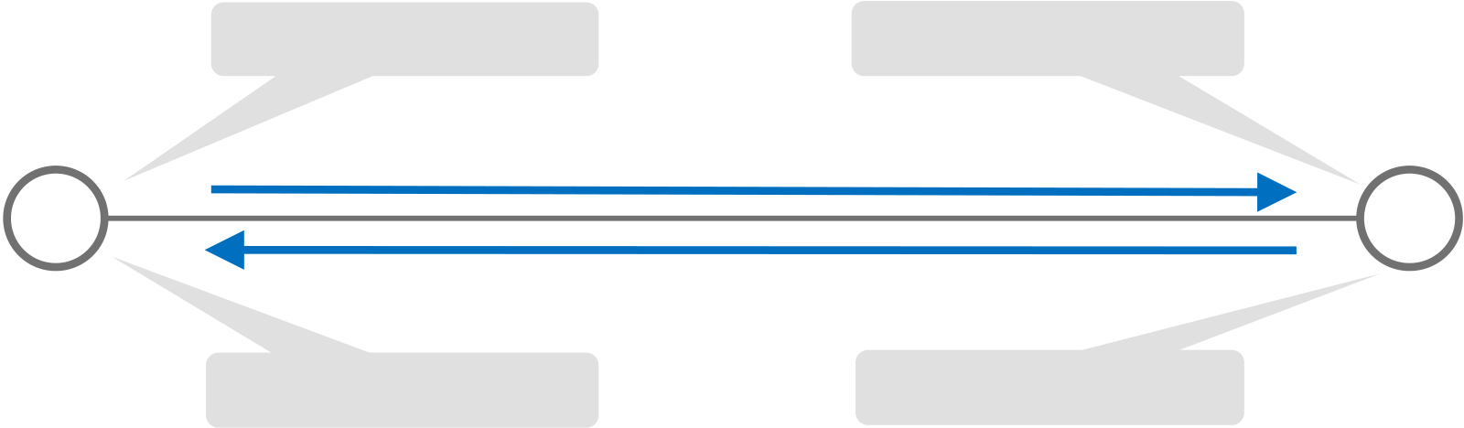

Link Delay Measurement

TX Timestamp T1 RX Timestamp T2

**PM Query Packet**

|  |  |  |  |
| --- | --- | --- | --- |
| Local-end | 1 | 2 | Remote-end |

**PM Response Packet**

RX Timestamp T4 TX Timestamp T3

|  |
| --- |
| • Two-Way Delay = (T2 – T1) + (T4 – T3) = (T4 – T1) – (T3 – T2)  • One-way Delay = (Two-Way Delay)/2 |

|  |
| --- |
| • Measure link delay to compute path latency• Advertised via IGP TE Metric Extensions• SRTE optimize path on min-delay  # show isis database R1 verbose | i Delay Link Average Delay: 7 us  Link Min/Max Delay: 7/7 us |

|  |  |  |  |  |
| --- | --- | --- | --- | --- |
|  | #CLUS | BRKMPL-2130 | © 2019 Cisco and/or its affiliates. All rights reserved. Cisco Public | 55 |

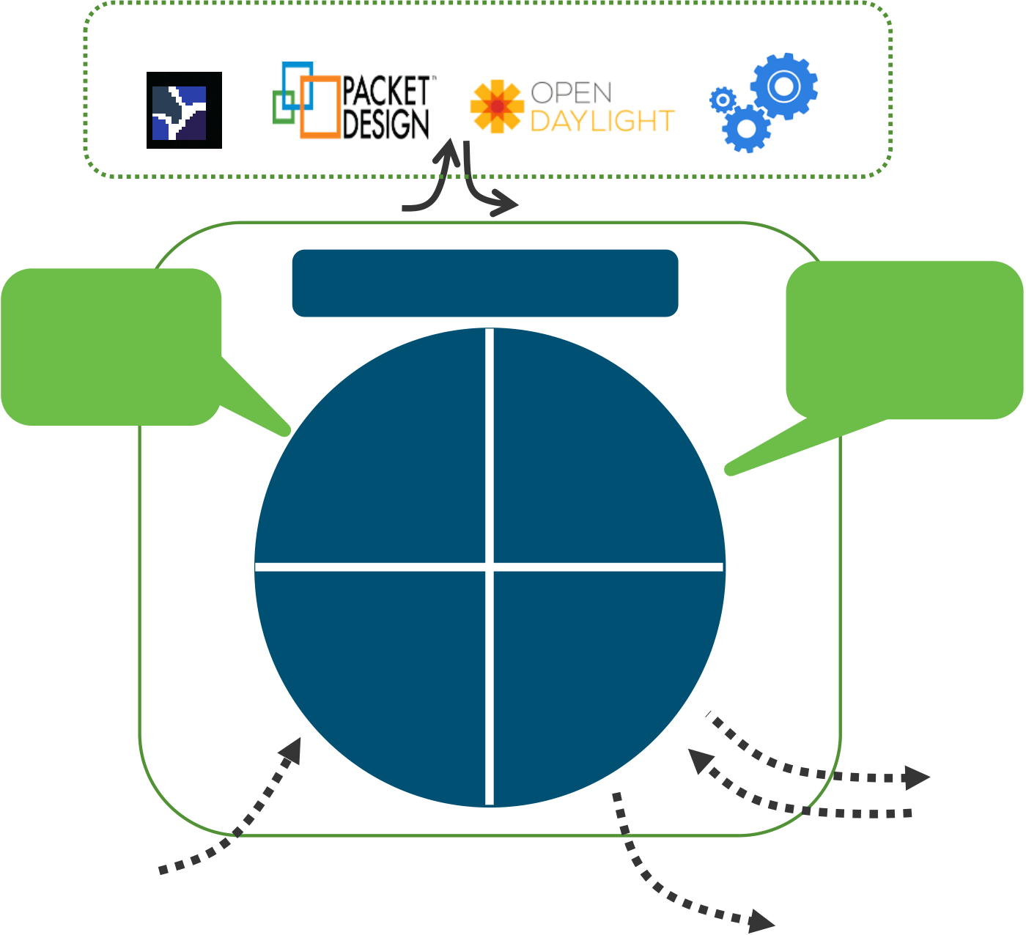

SR-PCE Controller Architecture

|  |  |  |
| --- | --- | --- |
| CrossWorks | REST API | Custom app |
| Multi- | Native SR |
| Domain |
| algorithms |
| Topology |

|  |  |  |  |  |  |  |
| --- | --- | --- | --- | --- | --- | --- |
|  | IGP  BGP-LS | Topo  DB | Compute | | PCEP | 56 |
| Collect | Deploy | |
| MP-BGP | | © 2019 Cisco and/or its affiliates. All rights reserved. Cisco Public |
| #CLUS | BRKMPL-2130 |

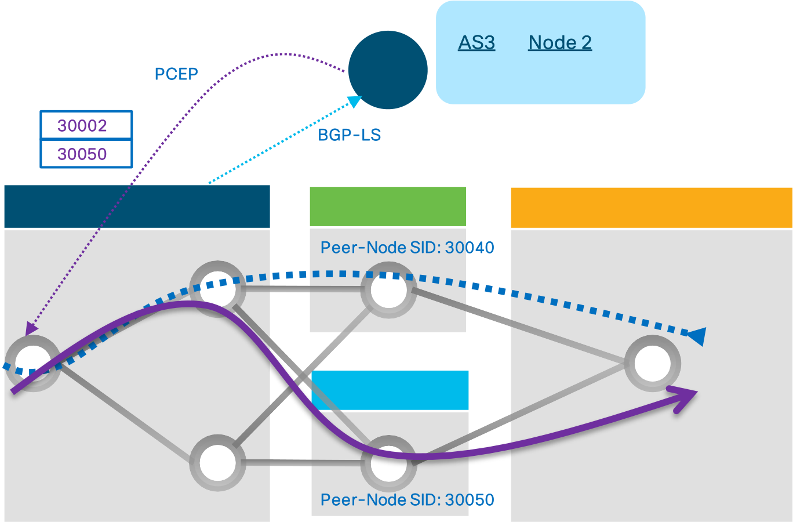

|  |  |  |  |
| --- | --- | --- | --- |
| Egress Peer Engineering (EPE) | PCEP | SR | Setup EPE so that |
| Applicability Examples | AS3 via Node 2 is |
| used when sending |
| **Internet Peering** | PCE |
| traffic to AS4 |
| 30002 | BGP-LS |

30050

|  |  |  |  |  |  |
| --- | --- | --- | --- | --- | --- |
| Engineered  Exit Points |  | AS1 | 2 | AS2 | AS4 |
| Peer-Node SID: 30040 |
| 4 |
| Solution |  |  |  |  |  |
| SDN controller based approach to instruct an ingress PE to | 1 |  | 3 | AS3 | 6 |
| use a specific egress PE and a specific external |
| interface/neighbor to reach a particular destination. | 5 |

Peer-Node SID: 30050

|  |  |  |
| --- | --- | --- |
| Benefits |  |  |
| Intent-based |  | BGP Best-Path |
| SLA-aware BGP service |
| Optimal decisions based on cost, latency, loss | EPE Path |

|  |  |  |  |  |
| --- | --- | --- | --- | --- |
| Optimal use of resources | #CLUS | BRKMPL-2130 | © 2019 Cisco and/or its affiliates. All rights reserved. Cisco Public | 57 |
|  |